Marine Safety Enhancement Using Faster R-CNN with VGG16 for Ship Detection from Airborne Radar Signals
INTRODUCTION
High ship density and illegitimate shipping activities (e.g., piracy and illegal fishing) are ongoing challenges for coastal authorities. For enhancing the current maritime situation awareness, near real-time ship detection as a part of ship monitoring is needed. Popular and prevalent systems used for ship monitoring applications are onboard transponder based systems, such as the automatic identification system (AIS) and marine radars. However, these systems have major drawbacks not all ships, especially the smaller ones, are obligated to carry an AIS transponder the reliability of transponder-based systems depends on the cooperation of the ships; and the marine radars are limited by their acquisition range. To overcome these shortcomings, air- and spaceborne radars have been used as additional data sources. These radars offer great potential for ship monitoring due to their ability to cover wide areas and acquire high-resolution data independent of prevailing weather and daylight conditions. Unlike spaceborne radars, airborne radars can achieve both shorter revisits and longer observation times, but not at global coverage. Conventionally, ship detection methods are based on constant false alarm rate (CFAR), which are powerful and well-known in the open literature. However, they may have some drawbacks for their operational use. For instance, in high-resolution radar data, a single ship can be composed of thousands of detected pixels. Therefore, after detection, additional postprocessing (e.g., clustering) becomes necessary to come up with ship objects, which increases the computation time. Furthermore, since most CFAR-based algorithms operate on single pixels but not objects, a number of false detections may be obtained from other marine objects or from high-intensity ocean clutter. An additional postprocessing may be needed afterward for reducing the number of false detections. Recent studies have shown that the application of deep learning techniques for ship detection can be a great alternative with very promising results. In particular, the faster region-based convolutional neural network (R-CNN) is currently one of the most employed deep learning frameworks for ship detection in radar imagery. Most deep learning techniques developed for ship detection are primarily applied on fully focused synthetic aperture radar (SAR) images. SAR image generation is a time-consuming process and is generally not suitable for ship detection with real-time capability. One potential solution for achieving future real-time ship detection capability is the use of Range-Compressed (RC) radar data. Unlike in fully focused SAR images, for RC data, no range cell migration correction and azimuth compression using reference functions have to be carried out, which significantly reduces the overall processing time. The RC airborne radar data are even more attractive from the point of view that the signal-to-noise ratio in most cases is sufficiently large, and they allow for long observation times which enable continuous monitoring of hotspots. To the authors’ knowledge, the applicability of deep learning techniques to RC radar data for ship detection has not yet been intensively investigated. In this letter, two novel deep learning methodologies are proposed for detecting the ships using RC airborne radar data. The first framework detects the ships in time domain, while the second detects the ships in Doppler domain. The detectors are based on the Faster R-CNN framework with a ResNet-50 backbone, which is well-established for ship detection and thus provides a suitable baseline for initial investigations. They are trained and tested based on eleven real X-band RC radar datasets acquired with DLR’s airborne systems F-SAR and DBFSAR (with digital beamforming capabilities). In addition, this letter presents a detailed comparison between the proposed detectors and a state-of-the-art CFAR-based ship detector. The remainder of this letter is organized as follows. Section II describes the process of generating training and testing datasets. Section reviews the Faster R-CNN framework. Section IV introduces the study area and the acquired datasets. Section presents and discusses the experimental results. Section summarizes the results and concludes the letter.
1.1 Objective of the project:
Near real-time ship monitoring is crucial for ensuring safety and security at sea. Established ship monitoring systems are the automatic identification system (AIS) and marine radars. However, not all ships are committed to carry an AIS transponder and the marine radars suffer from limited visibility. For these reasons, airborne radars can be used as an additional and supportive sensor for ship monitoring, especially on the open sea. State-of-the-art algorithms for ship detection in radar imagery are based on constant false alarm rate (CFAR). Such algorithms are pixel-based and therefore it can be challenging in practice to achieve near real-time detection. This letter presents two object-oriented ship detectors based on the faster region-based convolutional neural network (R-CNN). The first detector operates in time domain and the second detector operates in Doppler domain of airborne Range-Compressed (RC) radar data patches. The Faster R-CNN models are trained on thousands of real X-band airborne RC radar data patches containing several ship signals. The robustness of the proposed object-oriented ship detectors is tested on multiple scenarios, showing high recall performance of the models even in very dense multitarget scenarios in the complex inshore environment of the North Sea.
2. LITERATURE SURVEY:
"Satellite imaging for maritime surveillance of the European seas"
H. Greidanus, 2008.
Surveillance of ships at sea poses particular challenges for spaceborne sensors: small targets need to be detected, wide areas need to be surveyed, and both targets and background are anything but stationary. Incidental, snap-shot images find their application niches – among the existing technologies for ship monitoring – mostly in alerting to the presence of unknown targets and in surveying outlying areas. The main applications in the European seas cover fisheries control, pollution control and maritime border security, although operational use is still sporadic. The sensor of choice is SAR, because it allows ship detection over wide swaths and under many conditions. High-resolution optical sensors can provide additional information on ship classification, which is still difficult for SAR. Their narrow swaths, however, mostly limit their use to predetermined locations. Clutter from the sea surface hinders detection of the smallest ships, especially at high sea state, leading to false alarms and to less than 100% detection probability. For many applications these drawbacks can be kept within acceptable limits by proper choice of the swath width/Reso- lotion combination. Satellite sensors may also image ship wakes, from which information on ship speed and heading can be gleaned. Crucial to operational use is the ability for automatic analysis. This is relatively well developed for ship detection, and less well for classification and wake analysis, in SAR images, and quite immature for optical images.
"A tutorial on synthetic aperture radar"
A. Moreira, P. Prats-Iraola, M. Younis, G. Krieger, I. Hanse and K. P. Papathanassiou, Mar. 2013.
Synthetic Aperture Radar (SAR) has been widely used for Earth remote sensing for more than 30 years. It provides high-resolution, day-and-night and weather-independent images for a multitude of applications ranging from geoscience and climate change research, environmental and Earth system monitoring, 2-D and 3-D mapping, change detection, 4-D mapping (space and time), security-related applications up to planetary exploration. With the advances in radar technology and geo/bio-physical parameter inversion modeling in the 90s, using data from several airborne and spaceborne systems, a paradigm shift occurred from the development driven by the technology push to the user demand pull. Today, more than 15 spaceborne SAR systems are being operated for in numerous applications. This paper provides first a tutorial about the SAR principles and theory, followed by an overview of established techniques like polarimetry, interferometry and differential interferometry as well as of emerging techniques (e.g., polarimetric SAR interferometry, tomography and holographic tomography). Several application examples including the associated parameter inversion modeling are provided for each case. The paper also describes innovative technologies and concepts like digital beamforming, Multiple-Input Multiple-Output (MIMO) and bi- and multi-static configurations which are suitable means to fulfil the increasing user requirements. The paper concludes with a vision for SAR remote sensing.
"Review of ship detection from airborne platforms"
M. F. Finglas and C. E. Brown, 2001.
Ship detection has been playing a significant role in the field of remote sensing for a long time, but it is still full of challenges. The main limitations of traditional ship detection methods usually lie in the complexity of application scenarios, the difficulty of intensive object detection, and the redundancy of the detection region. In order to solve these problems above, we propose a framework called Rotation Dense Feature Pyramid Networks (R-DFPN) which can effectively detect ships in different scenes including ocean and port. Specifically, we put forward the Dense Feature Pyramid Network (DFPN), which is aimed at solving problems resulting from the narrow width of the ship. Compared with previous multiscale detectors such as Feature Pyramid Network (FPN), DFPN builds high-level semantic feature-maps for all scales by means of dense connections, through which feature propagation is enhanced and feature reuse is encouraged. Additionally, in the case of ship rotation and dense arrangement, we design a rotation anchor strategy to predict the minimum circumscribed rectangle of the object so as to reduce the redundant detection region and improve the recall. Furthermore, we also propose multiscale region of interest (ROI) Align for the purpose of maintaining the completeness of the semantic and spatial information. Experiments based on remote sensing images from Google Earth for ship detection show that our detection method based on R-DFPN representation has state-of-the-art performance.
"The state-of-the-art in ship detection in synthetic aperture radar imagery"
D. J. Crisp, 2004.
This report is a review of the pushily available literature on algorithms for detecting ships in Synthetic Aperture Radar (SAR) imagery, with the aim of recommending algorithms for inclusion in the Analysts' Detection Support System (ADSS). The ADSS is a software system being developed at DSTO for the automatic detection of targets in SAR imagery. We outline the motivations, theory and justifications of the various approaches so that educated comparisons and evaluations can be made. Most current research on ship detection is based on detecting the ship itself rather than its wake. Detection of ship wakes is not addressed in any depth. Ship detection systems generally consist of several stages: land masking; preprocessing; pre-screening; and discrimination. We consider each of these stages in turn and discuss the various algorithms which have been used. A basic system for low to medium resolution single channel SAR imagery is recommended and suggestions for improvements and alternatives are made.
"Range-Doppler based CFAR ship detection with automatic training data selection"
S. K. Joshi, S. V. Baumgartner, A. Barros Cardoso da Silva and G. Krieger, 2019.
Ship detection is an essential maritime security requirement. Current state-of-the-art synthetic aperture radar (SAR) based ship detection methods employ fully focused images. The time-consuming processing efforts required to generate these images make them generally unsuitable for real time applications. This paper proposes a novel real time oriented ship detection strategy applicable to range-compressed (RC) radar data acquired by an airborne radar sensor during linear, circular and arbitrary flight tracks. A constant false alarm rate (CFAR) detection threshold is computed in the range-Doppler domain using suitable distribution functions. Detection in range-Doppler has the advantage that principally even small ships with a low radar cross section (RCS) can be detected if they are moving fast enough so that the ship signals are shifted to the exon-clutter region. In order to determine a robust threshold, the ocean statistics have to be described accurately. Bright target peaks in the background ocean data bias the statistics and lead to an erroneous threshold. Therefore, an automatic ocean training data extraction procedure is proposed in the paper. It includes (1) a novel target pre-detection module that removes the bright peaks from the data already in time domain, (2) clutter normalization in the Doppler domain using the remaining samples, (3) ocean statistics estimation and (4) threshold computation. Various sea clutter models are investigated and analysed in the paper for finding the most suitable models for the RC data. The robustness and applicability of the proposed method is validated using real linearly and circularly acquired radar data from DLR’s (Deutsch’s Zentrum fur Luft- und Rampart) airborne F-SAR system.
"Ship classification in SAR images using a new hybrid CNN–MLP classifier"
F. Sharifzadeh, G. Akbari Zadeh and Y. Seifi Aviano. 2019.
Ship detection on the SAR images for marine monitoring has a wide usage. SAR technology helps us to have a better monitoring over intended sections, without considering atmospheric conditions, or image shooting time. In recent years, with advancements in convolutional neural network (CNN), which is one of the well-known ways of deep learning, using image deep features has increased. Recently, usage of CNN for SAR image segmentation has been increased. Existence of clutter edge, multiple interfering targets, speckle and sea-level clutters makes false alarms and false detections on detector algorithms. In this letter, constant false alarm rate is used for object recognition. This algorithm, processes the image pixel by pixel, and based on statistical information of its neighbors pixels, detects the targeted pixels. Afterward, a neural network with hybrid algorithm of CNN and multilayer perceptron (CNN–MLP) is suggested for image classification. In this proposal, the algorithm is trained with real SAR images from Sentinel-1 and RADARSAT-2 satellites, and has a better performance on object classification than state of the art.
"Object detection and image segmentation with deep learning on Earth observation data: A review—Part II: Applications"
T. Hoeser, F. Bachofer and C. Kuenzer, 2020.
In Earth observation (EO), large-scale land-surface dynamics are traditionally analysed by investigating aggregated classes. The increase in data with a very high spatial resolution enables investigations on a fine-grained feature level which can help us to better understand the dynamics of land surfaces by taking object dynamics into account. To extract fine-grained features and objects, the most popular deep-learning model for image analysis is commonly used: the convolutional neural network (CNN). In this review, we provide a comprehensive overview of the impact of deep learning on EO applications by reviewing 429 studies on image segmentation and object detection with CNNs. We extensively examine the spatial distribution of study sites, employed sensors, used datasets and CNN architectures, and give a thorough overview of applications in EO which used CNNs. Our main finding is that CNNs are in an advanced transition phase from computer vision to EO. Upon this, we argue that in the near future, investigations which analyse object dynamics with CNNs will have a significant impact on EO research. With a focus on EO applications in this Part II, we complete the methodological review provided in Part I.
"Deep learning meets SAR: Concepts models pitfalls and perspectives"
X. X. Zhu, Dec. 2021.
Deep learning in remote sensing has received considerable international hype, but it is mostly limited to the evaluation of optical data. Although deep learning has been introduced in synthetic aperture radar (SAR) data processing, despite successful first attempts, its huge potential remains locked. In this article, we provide an introduction to the most relevant deep learning models and concepts, point out possible pitfalls by analysing special characteristics of SAR data, review the state of the art of deep learning applied to SAR, summarize available benchmarks, and recommend some important future research directions. With this effort, we hope to stimulate more research in this interesting yet underexploited field and to pave the way for the use of deep learning in big SAR data processing workflows.
3. SYSTEM ANALYSIS

3.1 Existing System
Traditional ship detection systems rely on classical methods such as Constant False Alarm Rate (CFAR), Support Vector Machines (SVM), and threshold-based segmentation. These methods use handcrafted features and statistical models to identify ships from airborne radar data. While effective in controlled environments, they struggle in complex maritime scenarios with varying sea conditions, weather disturbances, and clutter interference, leading to reduced accuracy.

Disadvantages of Existing System
- High False Alarm Rate – Traditional methods are sensitive to noise and clutter, often misclassifying non-ship objects as ships.
- Limited Adaptability – Feature-based approaches fail to generalize well across different environments and radar conditions.
- Inefficient Processing – Many existing techniques require manual tuning and are computationally expensive, making them unsuitable for real-time applications.

3.2 Proposed System
The proposed system employs Faster R-CNN, a deep learning-based object detection framework, to accurately identify ships from range-compressed airborne radar data. Faster R-CNN integrates a convolutional neural network (CNN) for feature extraction and a Region Proposal Network (RPN) to detect potential ship locations automatically. By learning deep spatial features and patterns from radar images, the system improves detection accuracy, reduces false alarms, and operates efficiently in diverse maritime conditions.

Advantages of Proposed System
- Higher Detection Accuracy – Faster R-CNN enhances ship detection by leveraging deep learning, improving performance even in challenging environments.
- Reduced False Alarms – The model learns complex ship characteristics, minimizing misclassification due to clutter and noise.
- Real-Time Processing Capability – With GPU acceleration, Faster R-CNN can process radar data quickly, making it suitable for operational maritime surveillance.
Extension Concept
Resnet50 is the old model and Faster RCNN accuracy can be enhanced by employing advanced models so in extension work we have employed VGG16 as the base model for FRCNN and this algorithm giving high accuracy compare to propose FRCNN. Both algorithm performances are evaluated in terms of Accuracy, Precision, Recall and FSCORE.
3.3. PROCESS MODEL USED WITH JUSTIFICATION
SDLC (Umbrella Model):
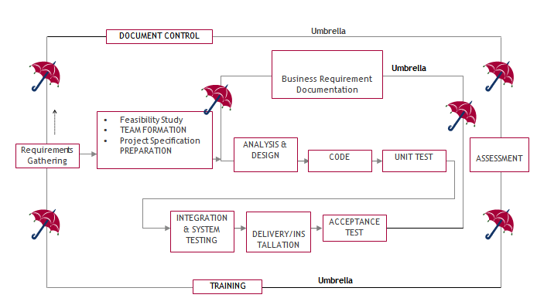

SDLC is nothing but Software Development Life Cycle. It is a standard which is used by software industry to develop good software.
Stages in SDLC:
- Requirement Gathering
- Analysis
- Designing
- Coding
- Testing
- Maintenance
Requirements Gathering stage:
The requirements gathering process takes as its input the goals identified in the high-level requirements section of the project plan. Each goal will be refined into a set of one or more requirements. These requirements define the major functions of the intended application, define operational data areas and reference data areas, and define the initial data entities. Major functions include critical processes to be managed, as well as mission critical inputs, outputs and reports. A user class hierarchy is developed and associated with these major functions, data areas, and data entities. Each of these definitions is termed a Requirement. Requirements are identified by unique requirement identifiers and, at minimum, contain a requirement title and textual description.
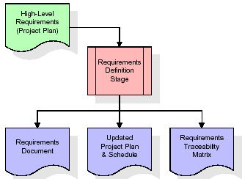
These requirements are fully described in the primary deliverables for this stage: the Requirements Document and the Requirements Traceability Matrix (RTM). The requirements document contains complete descriptions of each requirement, including diagrams and references to external documents as necessary. Note that detailed listings of database tables and fields are not included in the requirements document.
The title of each requirement is also placed into the first version of the RTM, along with the title of each goal from the project plan. The purpose of the RTM is to show that the product components developed during each stage of the software development lifecycle are formally connected to the components developed in prior stages.
In the requirements stage, the RTM consists of a list of high-level requirements, or goals, by title, with a listing of associated requirements for each goal, listed by requirement title. In this hierarchical listing, the RTM shows that each requirement developed during this stage is formally linked to a specific product goal. In this format, each requirement can be traced to a specific product goal, hence the term requirements traceability.
The outputs of the requirements definition stage include the requirements document, the RTM, and an updated project plan.
- Feasibility study is all about identification of problems in a project.
- No. of staff required to handle a project is represented as Team Formation, in this case only modules are individual tasks will be assigned to employees who are working for that project.
- Project Specifications are all about representing of various possible inputs submitting to the server and corresponding outputs along with reports maintained by administrator.
Analysis Stage:
The planning stage establishes a bird's eye view of the intended software product, and uses this to establish the basic project structure, evaluate feasibility and risks associated with the project, and describe appropriate management and technical approaches.
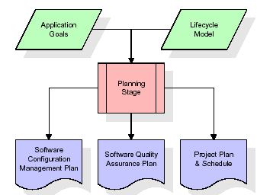
The most critical section of the project plan is a listing of high-level product requirements, also referred to as goals. All of the software product requirements to be developed during the requirements definition stage flow from one or more of these goals. The minimum information for each goal consists of a title and textual description, although additional information and references to external documents may be included. The outputs of the project planning stage are the configuration management plan, the quality assurance plan, and the project plan and schedule, with a detailed listing of scheduled activities for the upcoming Requirements stage, and high level estimates of effort for the out stages.
Designing Stage:
The design stage takes as its initial input the requirements identified in the approved requirements document. For each requirement, a set of one or more design elements will be produced as a result of interviews, workshops, and/or prototype efforts. Design elements describe the desired software features in detail, and generally include functional hierarchy diagrams, screen layout diagrams, tables of business rules, business process diagrams, pseudo code, and a complete entity-relationship diagram with a full data dictionary. These design elements are intended to describe the software in sufficient detail that skilled programmers may develop the software with minimal additional input.
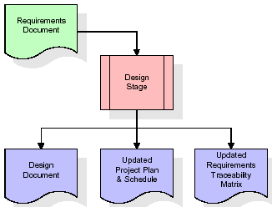
When the design document is finalized and accepted, the RTM is updated to show that each design element is formally associated with a specific requirement. The outputs of the design stage are the design document, an updated RTM, and an updated project plan.
Development (Coding) Stage:
The development stage takes as its primary input the design elements described in the approved design document. For each design element, a set of one or more software artifacts will be produced. Software artifacts include but are not limited to menus, dialogs, and data management forms, data reporting formats, and specialized procedures and functions. Appropriate test cases will be developed for each set of functionally related software artifacts, and an online help system will be developed to guide users in their interactions with the software.
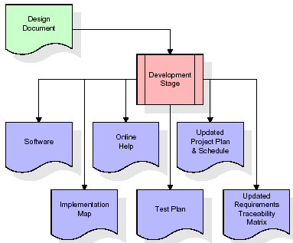

The RTM will be updated to show that each developed artifact is linked to a specific design element, and that each developed artifact has one or more corresponding test case items. At this point, the RTM is in its final configuration. The outputs of the development stage include a fully functional set of software that satisfies the requirements and design elements previously documented, an online help system that describes the operation of the software, an implementation map that identifies the primary code entry points for all major system functions, a test plan that describes the test cases to be used to validate the correctness and completeness of the software, an updated RTM, and an updated project plan.
Integration & Test Stage:
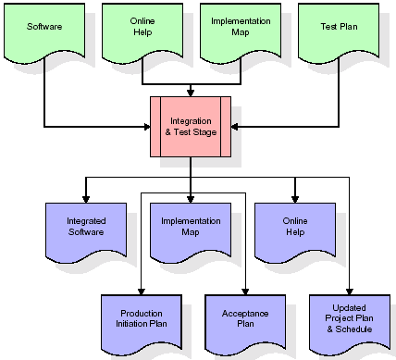
During the integration and test stage, the software artifacts, online help, and test data are migrated from the development environment to a separate test environment. At this point, all test cases are run to verify the correctness and completeness of the software. Successful execution of the test suite confirms a robust and complete migration capability. During this stage, reference data is finalized for production use and production users are identified and linked to their appropriate roles. The final reference data (or links to reference data source files) and production user list are compiled into the Production Initiation Plan.

The outputs of the integration and test stage include an integrated set of software, an online help system, an implementation map, a production initiation plan that describes reference data and production users, an acceptance plan which contains the final suite of test cases, and an updated project plan.
- Installation & Acceptance Test:
During the installation and acceptance stage, the software artifacts, online help, and initial production data are loaded onto the production server. At this point, all test cases are run to verify the correctness and completeness of the software. Successful execution of the test suite is a prerequisite to acceptance of the software by the customer.
After customer personnel have verified that the initial production data load is correct and the test suite has been executed with satisfactory results, the customer formally accepts the delivery of the software.
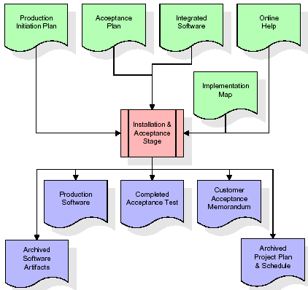
The primary outputs of the installation and acceptance stage include a production application, a completed acceptance test suite, and a memorandum of customer acceptance of the software. Finally, the PDR enters the last of the actual labor data into the project schedule and locks the project as a permanent project record. At this point the PDR "locks" the project by archiving all software items, the implementation map, the source code, and the documentation for future reference.
Maintenance:
Outer rectangle represents maintenance of a project, Maintenance team will start with requirement study, understanding of documentation later employees will be assigned work and they will undergo training on that particular assigned category. For this life cycle there is no end, it will be continued so on like an umbrella (no ending point to umbrella sticks).
3.4. Software Requirement Specification
3.4.1. Overall Description
A Software Requirements Specification (SRS) – a requirements specification for a software system is a complete description of the behaviour of a system to be developed. It includes a set of use cases that describe all the interactions the users will have with the software. In addition to use cases, the SRS also contains non-functional requirements. Non-functional requirements are requirements which impose constraints on the design or implementation (such as performance engineering requirements, quality standards, or design constraints).
System requirements specification: A structured collection of information that embodies the requirements of a system. A business analyst, sometimes titled system analyst, is responsible for analysing the business needs of their clients and stakeholders to help identify business problems and propose solutions. Within the systems development lifecycle domain, the BA typically performs a liaison function between the business side of an enterprise and the information technology department or external service providers. Projects are subject to three sorts of requirements:
- Business requirements describe in business terms what must be delivered or accomplished to provide value.
- Product requirements describe properties of a system or product (which could be one of several ways to accomplish a set of business requirements.)
- Process requirements describe activities performed by the developing organization. For instance, process requirements could specify .Preliminary investigation examine project feasibility, the likelihood the system will be useful to the organization. The main objective of the feasibility study is to test the Technical, Operational and Economical feasibility for adding new modules and debugging old running system. All system is feasible if they are unlimited resources and infinite time. There are aspects in the feasibility study portion of the preliminary investigation:
- ECONOMIC FEASIBILITY
A system can be developed technically and that will be used if installed must still be a good investment for the organization. In the economic feasibility, the development cost in creating the system is evaluated against the ultimate benefit derived from the new systems. Financial benefits must equal or exceed the costs. The system is economically feasible. It does not require any addition hardware or software. Since the interface for this system is developed using the existing resources and technologies available at NIC, there is nominal expenditure and economic feasibility for certain.
- Operational Feasibility
Proposed projects are beneficial only if they can be turned out into information system. That will meet the organization’s operating requirements. Operational feasibility aspects of the project are to be taken as an important part of the project implementation. This system is targeted to be in accordance with the above-mentioned issues. Beforehand, the management issues and user requirements have been taken into consideration. So there is no question of resistance from the users that can undermine the possible application benefits. The well-planned design would ensure the optimal utilization of the computer resources and would help in the improvement of performance status.
- TECHNICAL FEASIBILITY
Earlier no system existed to cater to the needs of ‘Secure Infrastructure Implementation System’. The current system developed is technically feasible. It is a web-based user interface for audit workflow at NIC-CSD. Thus, it provides an easy access to. the users. The database’s purpose is to create, establish and maintain a workflow among various entities in order to facilitate all concerned users in their various capacities or roles. Permission to the users would be granted based on the roles specified. Therefore, it provides the technical guarantee of accuracy, reliability and security.
3.4.2. External Interface Requirements
User Interface
The user interface of this system is a user friendly python Graphical User Interface.
Hardware Interfaces
The interaction between the user and the console is achieved through python capabilities.
Software Interfaces
The required software is python.
SYSTEM REQUIREMENT:
HARDWARE REQUIREMENTS:

Processor - Intel i3(min)
- Speed - 1.1 GHz
- RAM - 4GB(min)
- Hard Disk - 500 GB
SOFTWARE REQUIREMENTS:
- Operating System - Windows10(min)
- Programming Language - Python with Jupiter notebook

4. SYSTEM DESIGN
UML Diagram:
The Unified Modelling Language allows the software engineer to express an analysis model using the modelling notation that is governed by a set of syntactic semantic and pragmatic rules.
A UML system is represented using five different views that describe the system from distinctly different perspective. Each view is defined by a set of diagram, which is as follows.
  - User Model View
    - This view represents the system from the users perspective.
    - The analysis representation describes a usage scenario from the end-users perspective.
  - Structural Model view
    - In this model the data and functionality are arrived from inside the system.
    - This model view models the static structures.
- Behavioural Model View
It represents the dynamic of behavioural as parts of the system, depicting the interactions of collection between various structural elements described in the user model and structural model view.
- Implementation Model View
In this the structural and behavioural as parts of the system are represented as they are to be built.
- Environmental Model View
In this the structural and behavioural aspects of the environment in which the system is to be implemented are represented.
Class Diagram:
The class diagram is the main building block of object oriented modeling. It is used both for general conceptual modeling of the systematic of the application, and for detailed modeling translating the models into programming code. Class diagrams can also be used for data modeling. The classes in a class diagram represent both the main objects, interactions in the application and the classes to be programmed. In the diagram, classes are represented with boxes which contain three parts:
- The upper part holds the name of the class
- The middle part contains the attributes of the class
- The bottom part gives the methods or operations the class can take or undertake.

Use case Diagram:
A use case diagram at its simplest is a representation of a user's interaction with the system and depicting the specifications of a use case. A use case diagram can portray the different types of users of a system and the various ways that they interact with the system. This type of diagram is typically used in conjunction with the textual use case and will often be accompanied by other types of diagrams as well.

Sequence diagram:
A sequence diagram is a kind of interaction diagram that shows how processes operate with one another and in what order. It is a construct of a Message Sequence Chart. A sequence diagram shows object interactions arranged in time sequence. It depicts the objects and classes involved in the scenario and the sequence of messages exchanged between the objects needed to carry out the functionality of the scenario. Sequence diagrams are typically associated with use case realizations in the Logical View of the system under development. Sequence diagrams are sometimes called event diagrams, event scenarios, and timing diagrams.

Collaboration diagram:
A collaboration diagram describes interactions among objects in terms of sequenced messages. Collaboration diagrams represent a combination of information taken from class, sequence, and use case diagrams describing both the static structure and dynamic behaviour of a system.

Component Diagram:
In the Unified Modelling Language, a component diagram depicts how components are wired together to form larger components and or software systems. They are used to illustrate the structure of arbitrarily complex systems.
Components are wired together by using an assembly connector to connect the required interface of one component with the provided interface of another component. This illustrates the service consumer - service provider relationship between the two components.

Deployment Diagram:
A deployment diagram in the Unified Modeling Language models the physical deployment of artifacts on nodes. To describe a web site, for example, a deployment diagram would show what hardware components ("nodes") exist (e.g., a web server, an application server, and a database server), what software components ("artifacts") run on each node (e.g., web application, database), and how the different pieces are connected (e.g. JDBC, REST, RMI).
The nodes appear as boxes, and the artifacts allocated to each node appear as rectangles within the boxes. Nodes may have sub nodes, which appear as nested boxes. A single node in a deployment diagram may conceptually represent multiple physical nodes, such as a cluster of database servers.
Activity Diagram:
Activity diagram is another important diagram in UML to describe dynamic aspects of the system. It is basically a flow chart to represent the flow form one activity to another
activity. The activity can be described as an operation of the system. So the control flow is drawn from one operation to another. This flow can be sequential, branched or concurrent

Upload Dataset
Preprocess Dataset
Proposed ResNet50 Based FRCNN
Extension VGG16 based FRCNN
Accuracy Graph

Loss Graph
Comparison Graph

Ship Detection

Data Flow Diagram:
Data flow diagrams illustrate how data is processed by a system in terms of inputs and outputs. Data flow diagrams can be used to provide a clear representation of any business function. The technique starts with an overall picture of the business and continues by analysing each of the functional areas of interest. This analysis can be carried out in precisely the level of detail required. The technique exploits a method called top-down expansion to conduct the analysis in a targeted way.
As the name suggests, Data Flow Diagram (DFD) is an illustration that explicates the passage of information in a process. A DFD can be easily drawn using simple symbols. Additionally, complicated processes can be easily automated by creating DFDs using easy-to-use, free downloadable diagramming tools. A DFD is a model for constructing and analysing information processes. DFD illustrates the flow of information in a process depending upon the inputs and outputs. A DFD can also be referred to as a Process Model. A DFD demonstrates business or technical process with the support of the outside data saved, plus the data flowing from the process to another and the end results.
User

- Upload Dataset 1. Upload Dataset Successfully
- Preprocess Dataset 2. Preprocess Dataset Successfully
- Proposed Resnet50 Based FRCNN 3. Proposed Resnet50 Based FRCNN Successfully
- Extension VGG16 Based FRCNN 4. Extension VGG16 Based FRCNN Successfully
- Accuracy Graph 5. Accuracy Graph Displayed
- Loss Graph 6. Loss Graph Displayed
- Comparison Graph 7. Comparison Graph Displayed
- Ship Detection 8. Ship Detection Successfully

System

5. IMPLEMETATION
5.1 PYTHON
* One of the most popular languages is Python. Guido van Rossum released this language in 1991. Python is available on the Mac, Windows, and Raspberry Pi operating systems. The syntax of Python is simple and identical to that of English. When compared to Python, it was seen that the other language requires a few extra lines.
*It is an interpreter-based language because code may be run line by line after it has been written. This implies that rapid prototyping is possible across all platforms. Python is a big language with a free, binary-distributed interpreter standard library.
* It is inferior to maintenance that is conducted and is straightforward to learn. It is an object-oriented, interpreted programming language. It supports several different programming paradigms in addition to object-oriented programming, including functional and procedural programming.
* It supports several different programming paradigms in addition to object-oriented programming, including practical and procedural programming. Python is mighty while maintaining a relatively straightforward syntax. Classes, highly dynamic data types, modules, and exceptions are covered. Python can also be utilised by programmes that require programmable interfaces as an external language.
Here are some key features and characteristics of Python:
- Readability: Python emphasizes code readability with its clean and intuitive syntax. It uses indentation and whitespace to structure code blocks, making it easy to understand and maintain.
- Easy to Learn: Python's simplicity and readability make it an excellent choice for beginners. Its straightforward syntax and extensive documentation make it accessible for newcomers to programming.
- Interpreted Language: Python is an interpreted language, meaning that it doesn't need to be compiled before running. The Python interpreter reads and executes the code directly, making the development process faster and more interactive.
- Cross-platform Compatibility: Python is available for major operating systems like Windows, macOS, and Linux. This cross-platform compatibility allows developers to write code once and run it on different platforms without modifications.
- Large Standard Library: Python comes with a vast standard library that provides ready-to-use modules and functions for various tasks. It covers areas such as file I/O, networking, regular expressions, databases, and more, saving developers time and effort.
- Extensible and Modular: Python supports modular programming, enabling developers to organize code into reusable modules and packages. Additionally, Python allows integrating modules written in other languages, such as C or C++, providing flexibility and performance optimizations.
- Wide Range of Libraries and Frameworks: Python has a vibrant ecosystem with numerous third-party libraries and frameworks. These libraries, such as NumPy, pandas, TensorFlow, and Django, extend Python's capabilities for specific domains, making it a powerful tool for diverse applications.
- Object-Oriented: Python supports object-oriented programming (OOP) principles, allowing developers to create and work with classes and objects. OOP provides a structured approach to code organization, promoting code reuse and modularity.
- Dynamic Typing: Python is dynamically typed, meaning variable types are determined at runtime. Developers do not need to declare variable types explicitly, which enhances flexibility and simplifies code writing.
5.2 Installation
To install Python on your computer, follow these basic steps:
- Step 1: Visit the Python website Go to the official Python website at https://www.python.org/.
- Step 2: Select the operating system Choose the appropriate installer for your operating system. Python supports Windows, macOS, and various Linux distributions. Make sure to select the correct version that matches your operating system.
- Step 3: Check which version of Python is installed; if the 3.7.0 version is not there, uninstall it through the control panel and
- Step 4: Install Python 3.7.0 using Cmd.
- Step 5: Install the all libraries that required to run the project
- Step 6: Run
5.3 Python Features:
- Easy: Because Python is a more accessible and straightforward language, Python programming is easier to learn.
- Interpreted language: Python is an interpreted language, therefore it can be used to examine the code line by line and provide results.
- Open Source: Python is a free online programming language since it is open-source.
- Portable: Python is portable because the same code may be used on several computer standard
- libraries: Python offers a sizable library that we may utilize to create applications quickly.
- GUI: It stands for GUI (Graphical User Interface)
- Dynamical typed: Python is a dynamically typed language, therefore the type of the value will be determined at runtime.
5.4 Python GUI (Tkinter)
- Python provides a wide range of options for GUI development (Graphical User Interfaces).
- Tkinter, the most widely used GUI technique, is used for all of them.
- The Tk GUI toolkit offered by Python is used with the conventional Python interface.
- Tkinter is the easiest and quickest way to write Python GUI programs.
- Using Tkinter, creating a GUI is simple.
- A part of Python's built-in library is Tkinter. The GUI programs were created.
- Python and Tkinter together give a straightforward and quick way. The Tk GUI toolkit's object-oriented user interface is called Tkinter.

Making a GUI application is easy using Tkinter. Following are the steps:
1) Install the Tkinter module in place.
2) The GUI application Makes the primary window
3) Include one or more of the widgets mentioned above in the GUI application.
4) Set up the main event loop such that it reacts to each user-initiated event.
Although Tkinter is the only GUI framework included in the Python standard library, Python includes a GUI framework. The default library for Python is called Tkinter. Tk is a scripting language often used in designing, testing, and developing GUIs. Tk is a free, open-source widget toolkit that may be used to build GUI applications in a wide range of computer languages.
5.5 Python IDLE
- Python IDLE offers a full-fledged file editor, which gives you the ability to write and execute Python programs from within this program. The built-in file editor also includes several features, like code completion and automatic indentation, that will speed up your coding workflow.
- Guido Van Rossum named Python after the British comedy group Monty Python while the name IDLE was chosen to pay tribute to Eric Idle, who was one of the Monty Python's founding members. IDLE comes bundled with the default implementation of the Python language since the 01.5. 2b1 release
- IDLE is used to execute statements similar to Python Shell. IDLE is used to create, modify, and execute Python code. IDLE provides a fully-featured text editor to write Python scripts and provides features like syntax highlighting, auto-completion, and smart indent.
- IDLE has two modes: interactive and script. We wrote our first program, “Hello, World!” in interactive mode. Interactive mode immediately returns the results of commands you enter into the shell. In script mode, you will write a script and then run it.
- The IDE Python IDLE is a good place to start as it helps you become familiar with the way Python works and understand its syntax. This IDE is good to start programming in Python due to its great debugger, but once you are fluent and start developing projects it is necessary to jump to another, more complete IDE.
- Python IDLE (Integrated Development and Learning Environment) is an interactive development environment included with the Python programming language. It provides a convenient way to write, execute, and debug Python code.
When you install Python, IDLE is typically installed along with it. To open IDLE, you can follow these steps:
- Open the command prompt (Windows) or terminal (macOS/Linux).
- Type "idle" and press Enter. Alternatively, you can specify the version with "idle3" or "idle2" for Python 3 or Python 2, respectively.
- Once IDLE is launched, you will see the Python shell, which is an interactive environment where you can type and execute Python code directly.
Here are some features and functionalities provided by Python IDLE:
- Editor: IDLE includes a text editor where you can write your Python code. It offers syntax highlighting, automatic indentation, and code completion to enhance your coding experience.
- Interactive Shell: The Python shell in IDLE allows you to execute Python code interactively. You can type commands, statements, or function calls directly in the shell, and Python will execute them immediately.
- Debugging: IDLE provides basic debugging capabilities to help you find and fix errors in your code. You can set breakpoints, step through code, inspect variables, and track the program's execution.
- Python Help: IDLE provides access to the Python documentation and built-in help. You can access the help menu to find information about Python modules, functions, classes, and more.
- Script Execution: In addition to the interactive shell, IDLE allows you to run Python scripts stored in files. You can write your code in the editor and execute it as a script to see the output or interact with the program.
- Customization: IDLE can be customized to suit your preferences. You can modify settings related to syntax highlighting, indentation, fonts, and more.
- Python IDLE serves as a beginner-friendly development environment and learning tool. It is suitable for writing small scripts, testing code snippets, experimenting with Python features, and learning the language's basics. However, for more advanced development projects, you may consider using other code editors or integrated development environments (IDEs) that provide additional features and better project management capabilities.
5.6 Libraries
In Python, libraries (also referred to as modules or packages) are collections of pre-written code that provide additional functionality and tools to extend the capabilities of the Python language. Libraries contain reusable code that developers can leverage to perform specific tasks without having to write everything from scratch.
Python libraries are designed to solve common problems, such as handling data, performing mathematical operations, interacting with databases, working with files, implementing networking protocols, creating graphical user interfaces (GUIs), and much more. They provide ready-to-use functions, classes, and methods that simplify complex operations and save development time.
Libraries in Python offer various advantages:
- Code Reusability:
- Efficiency:
- Collaboration
- Domain-Specific Functionality
- To use a Python library, you need to install it first.
There are some libraries following:
- Pandas:
Pandas are a Python computer language library for data analysis and manipulation. It offers a specific operation and data format for handling time series and numerical tables. It differs significantly from the release3-clause of the BSD license. It is a well-liked open-source of opinion that is utilized in machine learning and data analysis.
Pandas are a Python package providing fast, flexible, and expressive data structures designed to make working with “relational” or “labeled” data both easy and intuitive. It aims to be the fundamental high-level building block for doing practical, real-world data analysis in Python. Pandas are a Python library used for working with data sets.
- It has functions for analysing, cleaning, exploring, and manipulating data.
- The name "Pandas" has a reference to both "Panel Data", and "Python Data Analysis" and was created by Wes McKinney in 2008.
- Pandas allow us to analyse big data and make conclusions based on statistical theories.
- Pandas can clean messy data sets, and make them readable and relevant.
Relevant data is very important in data science. Pandas are a Python library for data analysis. Started by Wes McKinney in 2008 out of a need for a powerful and flexible quantitative analysis tool, pandas have grown into one of the most popular Python libraries. It has an extremely active community of contributors. The name is derived from the term "panel data", an econometrics term for data sets that include observations over multiple time periods for the same individuals. Its name is a play on the phrase "Python data analysis" itself.
- NumPy:
The NumPy Python library for multi-dimensional, big-scale matrices adds a huge number of high-level mathematical functions. It is possible to modify NumPy by utilizing a Python library. Along with line, algebra, and the Fourier transform operations, it also contains several matrices-related functions.
NumPy can be used to perform a wide variety of mathematical operations on arrays. It adds powerful data structures to Python that guarantee efficient calculations with arrays and matrices and it supplies an enormous library of high-level mathematical functions that operate on these arrays and matrices.
- NumPy is a Python library used for working with arrays.
- It also has functions for working in domain of linear algebra, Fourier transform, and matrices.
- NumPy was created in 2005 by Travis Oliphant. It is an open source project and you can use it freely.
- NumPy stands for Numerical Python.
- In Python we have lists that serve the purpose of arrays, but they are slow to process.
- NumPy aims to provide an array object that is up to 50x faster than traditional Python lists.
- The array object in NumPy is called ndarray, it provides a lot of supporting functions that make working with ndarray very easy.
- Arrays are very frequently used in data science, where speed and resources are very important.

- Matplotlib:
It is a multi-platform, array-based data visualization framework built to interact with the whole SciPy stack. MATLAB is proposed as an open-source alternative. Matplotlib is a Python extension and a cross-platform toolkit for graphical plotting and visualization.
Matplotlib is a popular Python library for creating static, animated, and interactive visualizations. It provides a flexible and comprehensive set of tools for generating plots, charts, histograms, scatter plots, and more. Matplotlib is widely used in various fields, including data analysis, scientific research, and data visualization.
Here are some key features and functionalities of the Matplotlib library:
- Plotting Functions
- Customization Options
- Multiple Interfaces
- Integration with NumPy and pandas
- Subplots and Figures:
- Saving and Exporting

- Scikit-learn:
The most stable and practical machine learning library for Python is scikit-learn. Regression, dimensionality reduction, classification, and clustering are just a few of the helpful tools it provides through the Python interface for statistical modeling and machine learning. It is an essential part of the Python machine learning toolbox used by JP Morgan. It is frequently used in various machine learning applications, including classification and predictive analysis.
Scikit-learn (also referred to as sklearn) is a widely used open-source machine learning library for Python. It provides a comprehensive set of tools and algorithms for various machine learning tasks, including classification, regression, clustering, dimensionality reduction, model selection, and pre-processing.
Here are some key features and functionalities of the Scikit-learn library:
- Easy-to-Use Interface:
- Broad Range of Algorithms:
- Data Pre-processing and Feature Engineering:
- Model Evaluation and Validation:
- Integration with NumPy and pandas:
- Robust Documentation and Community Support:

- Keras:
* Google's Keras is a cutting-edge deep learning API for creating neural networks. It is created in Python and is designed to simplify the development of neural networks. Additionally, it enables the use of various neural networks for computation. Deep learning models are developed and tested using the free and open-source Python software known as Keras.
Keras is a high-level deep learning library for Python. It is designed to provide a user-friendly and intuitive interface for building and training deep learning models. Keras acts as a front-end API, allowing developers to define and configure neural networks while leveraging the computational backend engines, such as Tensor Flow or Theano.
Here are some key features and functionalities of the Keras library:
- User-Friendly API
- Multi-backend Support
- Wide Range of Neural Network Architectures
- Pre-trained Models and Transfer Learning:
- Easy Model Training and Evaluation:
- GPU Support:

- h5py:
* The h5py Python module offers an interface for the binary HDF5 data format. Thanks to p5py, the top can quickly halt the vast amount of numerical data and alter it using the NumPy library. It employs common syntax for Python, NumPy, and dictionary arrays.
h5py is a Python library that provides a simple and efficient interface for working with datasets and files in the Hierarchical Data Format 5 (HDF5) format. HDF5 is a versatile data format commonly used for storing and managing large volumes of numerical data.
Here are some key features and functionalities of the h5py library:
  - HDF5 File Access
  - Dataset Handling:
  - Group Organization:
  - Attributes:
  - Compatibility with NumPy
  - Performance

- Tensor flow
TensorFlow is a Python library for fast numerical computing created and released by Google. It is a foundation library that can be used to create Deep Learning models directly or by using wrapper libraries that simplify the process built on top of TensorFlow. TensorFlow is an end-to-end open source platform for machine learning. TensorFlow is a rich system for managing all aspects of a machine learning system; however, this class focuses on using a particular TensorFlow API to develop and train machine learning models.
TensorFlow is a popular open-source library for machine learning and deep learning. It provides a comprehensive set of tools, APIs, and computational resources for building and training various types of machine learning models, especially neural networks.
Here are some key features and functionalities of TensorFlow:
- Neural Network Framework:
- Computational Graphs
- Automatic Differentiation
- GPU and TPU Support
- Distributed Computing
- Deployment Capabilities

- Tkinter
Tkinter is an acronym for "Tk interface". Tk was developed as a GUI extension for the Tcl scripting language by John Ousterhout. The first release was in 1991. Tkinter is the de facto way in Python to create Graphical User interfaces (GUIs) and is included in all standard Python Distributions. In fact, it's the only framework built into the Python standard library.
Tkinter is a standard Python library used for creating graphical user interfaces (GUIs). It provides a set of modules and classes that allow you to develop interactive and visually appealing desktop applications.
Here are some key features and functionalities of Tkinter:
- Cross-Platform Compatibility
- Simple and Easy-to-Use
- Widgets and Layout Management
- Event-Driven Programming
- Customization and Styling
- Integration with Other Libraries

- NLTK
NLTK is a toolkit build for working with NLP in Python. It provides us various text processing libraries with a lot of test datasets. A variety of tasks can be performed using NLTK such as tokenizing, parse tree visualization, etc NLTK (Natural Language Toolkit) is the go-to API for NLP (Natural Language Processing) with Python. It is a really powerful tool to pre-process text data for further analysis like with ML models for instance. It helps convert text into numbers, which the model can then easily work with.
NLTK (Natural Language Toolkit) is a Python library widely used for working with human language data and implementing natural language processing (NLP) tasks. It provides a set of tools, corpora, and resources for tasks such as tokenization, stemming, tagging, parsing, sentiment analysis, and more.
Here are some key features and functionalities of NLTK:
- Text Processing
- Part-of-Speech Tagging
- Named Entity Recognition
- Chunking and Parsing
- Sentiment Analysis:
- WordNet Integration:

- Scipy
SciPy is a collection of mathematical algorithms and convenience functions built on the NumPy extension of Python. It adds significant power to the interactive Python session by providing the user with high-level commands and classes for manipulating and visualizing data.
SciPy is a powerful scientific computing library for Python that provides a wide range of mathematical algorithms and functions. It builds upon NumPy, another fundamental library for numerical computing, and extends its capabilities by adding additional tools for scientific and technical computing tasks.
Here are some key features and functionalities of SciPy:
- Numerical Integration:
- Optimization and Root Finding
- Linear Algebra
- Signal and Image Processing
- Statistics
Support Vector Machine (SVM):
Support Vector Machine (SVM) is a powerful machine learning algorithm used for linear or nonlinear classification, regression, and even outlier detection tasks. SVMs can be used for a variety of tasks, such as text classification, image classification, spam detection, handwriting identification, gene expression analysis, face detection, and anomaly detection. SVMs are adaptable and efficient in a variety of applications because they can manage high-dimensional data and nonlinear relationships. SVM algorithms are very effective as we try to find the maximum separating hyperplane between the different classes available in the target feature. Support Vector Machine (SVM) is a supervised machine learning algorithm used for both classification and regression. Though we say regression problems as well it’s best suited for classification. The main objective of the SVM algorithm is to find the optimal hyperplane in an N-dimensional space that can separate the data points in different classes in the feature space. The hyperplane tries that the margin between the closest points of different classes should be as maximum as possible. The dimension of the hyperplane depends upon the number of features. If the number of input features is two, then the hyperplane is just a line. If the number of input features is three, then the hyperplane becomes a 2-D plane. It becomes difficult to imagine when the number of features exceeds three.
Let’s consider two independent variables x₁, x_{2,} and one dependent variable which is either a blue circle or a red circle.
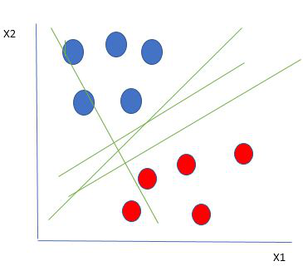
Linearly Separable Data points
From the figure above it’s very clear that there are multiple lines (our hyperplane here is a line because we are considering only two input features x₁, x₂) that segregate our data points or do a classification between red and blue circles. So how do we choose the best line or in general the best hyperplane that segregates our data points?

One reasonable choice as the best hyperplane is the one that represents the largest separation or margin between the two classes.
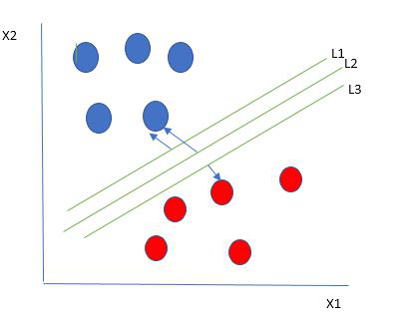
Multiple hyperplanes separate the data from two classes
So we choose the hyperplane whose distance from it to the nearest data point on each side is maximized. If such a hyperplane exists it is known as the maximum-margin hyperplane/hard margin. So from the above figure, we choose L2. Let’s consider a scenario like shown below
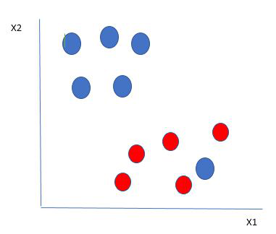
Selecting hyperplane for data with outlier
Here we have one blue ball in the boundary of the red ball. So how does SVM classify the data? It’s simple! The blue ball in the boundary of red ones is an outlier of blue balls. The SVM algorithm has the characteristics to ignore the outlier and finds the best hyperplane that maximizes the margin. SVM is robust to outliers.
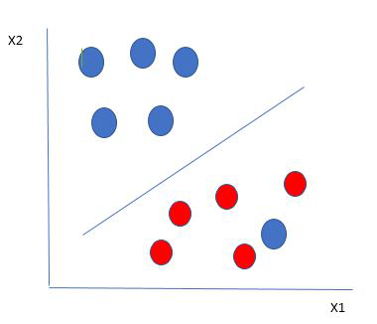
Hyperplane which is the most optimized one
So in this type of data point what SVM does is, finds the maximum margin as done with previous data sets along with that it adds a penalty each time a point crosses the margin. So the margins in these types of cases are called soft margins. When there is a soft margin to the data set, the SVM tries to minimize (1/margin+∧(∑penalty)). Hinge loss is a commonly used penalty. If no violations no hinge loss.If violations hinge loss proportional to the distance of violation.
Till now, we were talking about linearly separable data(the group of blue balls and red balls are separable by a straight line/linear line). What to do if data are not linearly separable?
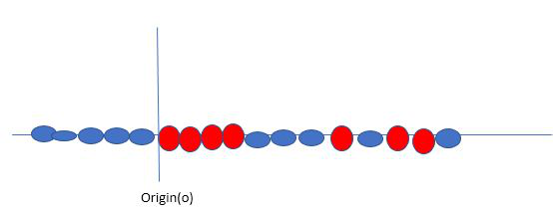
Original 1D dataset for classification
Say, our data is shown in the figure above. SVM solves this by creating a new variable using a kernel. We call a point x_{i} on the line and we create a new variable y_{i} as a function of distance from origin o.so if we plot this we get something like as shown below
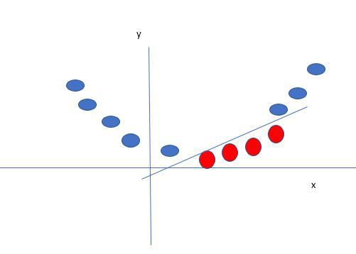
Mapping 1D data to 2D to become able to separate the two classes
In this case, the new variable y is created as a function of distance from the origin. A non-linear function that creates a new variable is referred to as a kernel.

Support Vector Machine Terminology
- Hyperplane: Hyperplane is the decision boundary that is used to separate the data points of different classes in a feature space. In the case of linear classifications, it will be a linear equation i.e. wx+b = 0.
- Support Vectors: Support vectors are the closest data points to the hyperplane, which makes a critical role in deciding the hyperplane and margin.
- Margin: Margin is the distance between the support vector and hyperplane. The main objective of the support vector machine algorithm is to maximize the margin. The wider margin indicates better classification performance.
- Kernel: Kernel is the mathematical function, which is used in SVM to map the original input data points into high-dimensional feature spaces, so, that the hyperplane can be easily found out even if the data points are not linearly separable in the original input space. Some of the common kernel functions are linear, polynomial, radial basis function(RBF), and sigmoid.
- Hard Margin: The maximum-margin hyperplane or the hard margin hyperplane is a hyperplane that properly separates the data points of different categories without any misclassifications.
- Soft Margin: When the data is not perfectly separable or contains outliers, SVM permits a soft margin technique. Each data point has a slack variable introduced by the soft-margin SVM formulation, which softens the strict margin requirement and permits certain misclassifications or violations. It discovers a compromise between increasing the margin and reducing violations.
- C: Margin maximisation and misclassification fines are balanced by the regularisation parameter C in SVM. The penalty for going over the margin or misclassifying data items is decided by it. A stricter penalty is imposed with a greater value of C, which results in a smaller margin and perhaps fewer misclassifications.
- Hinge Loss: A typical loss function in SVMs is hinge loss. It punishes incorrect classifications or margin violations. The objective function in SVM is frequently formed by combining it with the regularisation term.
- Dual Problem: A dual Problem of the optimisation problem that requires locating the Lagrange multipliers related to the support vectors can be used to solve SVM. The dual formulation enables the use of kernel tricks and more effective computing.

SVM implementation in Python
Predict if cancer is Benign or malignant. Using historical data about patients diagnosed with cancer enables doctors to differentiate malignant cases and benign ones are given independent attributes.

Steps
- Load the breast cancer dataset from sklearn.datasets
- Separate input features and target variables.
- Built and train the SVM classifiers using RBF kernel.
- Plot the scatter plot of the input features.
- Plot the decision boundary.
- Plot the decision boundary
Example:
# Load the important packages
from sklearn.datasets import load_breast_cancer
import matplotlib.pyplot as plt
from sklearn.inspection import DecisionBoundaryDisplay
from sklearn.svm import SVC
# Load the datasets
cancer = load_breast_cancer()
X = cancer.data[:, :2]
y = cancer.target
#Build the model
svm = SVC(kernel="rbf", gamma=0.5, C=1.0)
# Trained the model
svm.fit(X, y)
# Plot Decision Boundary
DecisionBoundaryDisplay.from_estimator(
svm,
X,
response_method="predict",
cmap=plt.cm.Spectral,
alpha=0.8,
xlabel=cancer.feature_names[0],
ylabel=cancer.feature_names[1],
)
# Scatter plot
plt.scatter(X[:, 0], X[:, 1], c=y, s=20, edgecolors="k")
plt.show()
Output:
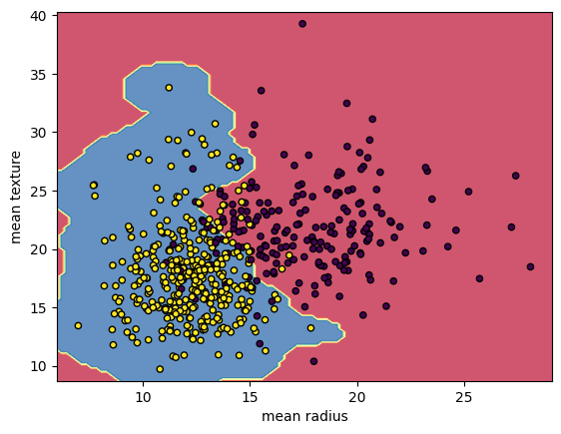
Breast Cancer Classifications with SVM RBF kernel

Convolution Neural Network
Convolutional Neural Network (CNN) is the extended version of artificial neural networks (ANN) which is predominantly used to extract the feature from the grid-like matrix dataset. For example visual datasets like images or videos where data patterns play an extensive role.

CNN architecture
Convolutional Neural Network consists of multiple layers like the input layer, Convolutional layer, Pooling layer, and fully connected layers.
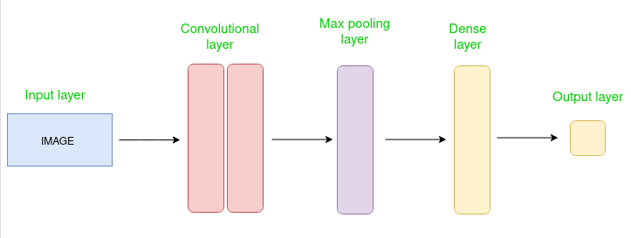
Simple CNN architecture
The Convolutional layer applies filters to the input image to extract features, the Pooling layer downsamples the image to reduce computation, and the fully connected layer makes the final prediction. The network learns the optimal filters through backpropagation and gradient descent.

How Convolutional Layers works
Convolution Neural Networks or covnets are neural networks that share their parameters. Imagine you have an image. It can be represented as a cuboid having its length, width (dimension of the image), and height (i.e the channel as images generally have red, green, and blue channels).
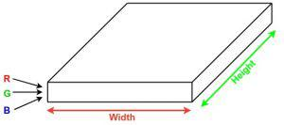
Now imagine taking a small patch of this image and running a small neural network, called a filter or kernel on it, with say, K outputs and representing them vertically. Now slide that neural network across the whole image, as a result, we will get another image with different widths, heights, and depths. Instead of just R, G, and B channels now we have more channels but lesser width and height. This operation is called Convolution. If the patch size is the same as that of the image it will be a regular neural network. Because of this small patch, we have fewer weights.
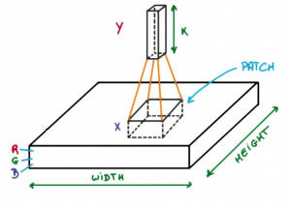
Image source: Deep Learning Udacity
Now let’s talk about a bit of mathematics that is involved in the whole convolution process.
- Convolution layers consist of a set of learnable filters (or kernels) having small widths and heights and the same depth as that of input volume (3 if the input layer is image input).
- For example, if we have to run convolution on an image with dimensions 34x34x3. The possible size of filters can be axax3, where ‘a’ can be anything like 3, 5, or 7 but smaller as compared to the image dimension.
- During the forward pass, we slide each filter across the whole input volume step by step where each step is called stride (which can have a value of 2, 3, or even 4 for high-dimensional images) and compute the dot product between the kernel weights and patch from input volume.
- As we slide our filters we’ll get a 2-D output for each filter and we’ll stack them together as a result, we’ll get output volume having a depth equal to the number of filters. The network will learn all the filters.

Layers used to build ConvNets
A complete Convolution Neural Networks architecture is also known as covnets. A covnets is a sequence of layers, and every layer transforms one volume to another through a differentiable function.
Types of layers:
datasets
Let’s take an example by running a covnets on of image of dimension 32 x 32 x 3.
- Input Layers: It’s the layer in which we give input to our model. In CNN, Generally, the input will be an image or a sequence of images. This layer holds the raw input of the image with width 32, height 32, and depth 3.
- Convolutional Layers: This is the layer, which is used to extract the feature from the input dataset. It applies a set of learnable filters known as the kernels to the input images. The filters/kernels are smaller matrices usually 2×2, 3×3, or 5×5 shape. it slides over the input image data and computes the dot product between kernel weight and the corresponding input image patch. The output of this layer is referred as feature maps. Suppose we use a total of 12 filters for this layer we’ll get an output volume of dimension 32 x 32 x 12.
- Activation Layer: By adding an activation function to the output of the preceding layer, activation layers add nonlinearity to the network. it will apply an element-wise activation function to the output of the convolution layer. Some common activation functions are RELU: max(0, x), Tanh, Leaky RELU, etc. The volume remains unchanged hence output volume will have dimensions 32 x 32 x 12.
- Pooling layer: This layer is periodically inserted in the covnets and its main function is to reduce the size of volume which makes the computation fast reduces memory and also prevents overfitting. Two common types of pooling layers are max pooling and average pooling. If we use a max pool with 2 x 2 filters and stride 2, the resultant volume will be of dimension 16x16x12.
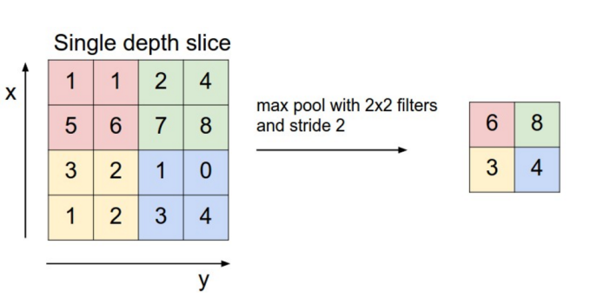
Image source: cs231n.stanford.edu
- Flattening: The resulting feature maps are flattened into a one-dimensional vector after the convolution and pooling layers so they can be passed into a completely linked layer for categorization or regression.
- Fully Connected Layers: It takes the input from the previous layer and computes the final classification or regression task.
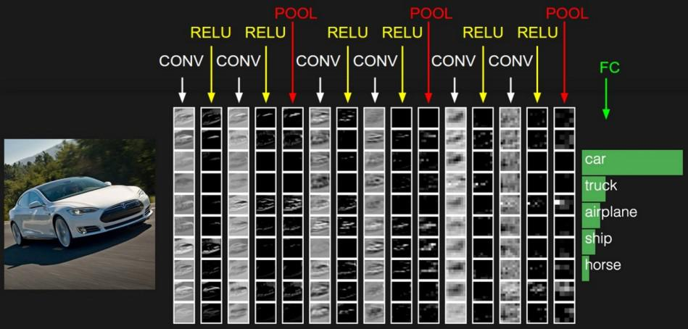
- Output Layer: The output from the fully connected layers is then fed into a logistic function for classification tasks like sigmoid or softmax which converts the output of each class into the probability score of each class.

VGG-16(Visual Geometry Group)
The VGG-16 model is a convolutional neural network (CNN) architecture that was proposed by the Visual Geometry Group (VGG) at the University of Oxford. It is characterized by its depth, consisting of 16 layers, including 13 convolutional layers and 3 fully connected layers. VGG-16 is renowned for its simplicity and effectiveness, as well as its ability to achieve strong performance on various computer vision tasks, including image classification and object recognition. The model’s architecture features a stack of convolutional layers followed by max-pooling layers, with progressively increasing depth. This design enables the model to learn intricate hierarchical representations of visual features, leading to robust and accurate predictions. Despite its simplicity compared to more recent architectures, VGG-16 remains a popular choice for many deep learning applications due to its versatility and excellent performance.
The ImageNet Large Scale Visual Recognition Challenge (ILSVRC) is an annual competition in computer vision where teams tackle tasks including object localization and image classification. VGG16, proposed by Karen Simonyan and Andrew Zisserman in 2014, achieved top ranks in both tasks, detecting objects from 200 classes and classifying images into 1000 categories.

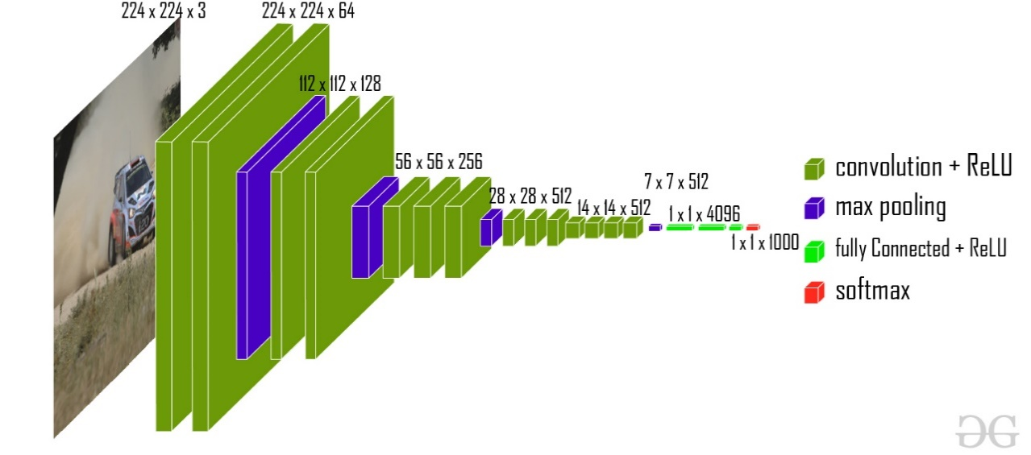
VGG-16 architecture

This model achieves 92.7% top-5 test accuracy on the ImageNet dataset which contains 14 million images belonging to 1000 classes.

VGG-16 Model Objective:
The ImageNet dataset contains images of fixed size of 224*224 and have RGB channels. So, we have a tensor of (224, 224, 3) as our input. This model process the input image and outputs a vector of 1000 values:
𝑦^=[𝑦0^𝑦1^𝑦2^...𝑦^999] y^​=​y0​^​y1​^​y2​^​...y^​999​​​
This vector represents the classification probability for the corresponding class. Suppose we have a model that predicts that the image belongs to class 0 with probability 1, class 1 with probability 0.05, class 2 with probability 0.05, class 3 with probability 0.03, class 780 with probability 0.72, class 999 with probability 0.05 and all other class with 0.
so, the classification vector for this will be:
𝑦^=[𝑦0^=0.10.050.050.03...𝑦780^=0.72..𝑦999^=0.05] y^​=​y0​^​=0.10.050.050.03...y780​^​=0.72..y999​^​=0.05​​
To make sure these probabilities add to 1, we use softmax function.
This softmax function is defined as follows:
𝑦^𝑖=𝑒𝑧𝑖∑𝑗=1𝑛𝑒𝑧𝑗y^​i​=∑j=1n​zed​eSig​​
After this we take the 5 most probable candidates into the vector.
𝐶=[780012999]C=​780012999​​
and our ground truth vector is defined as follows:
𝐺=[𝐺0𝐺1𝐺2]=[7802999] G=​G0​G1​G2​​​=​7802999​​
Then we define our Error function as follows:
𝐸=1𝑛∑𝑘𝑚𝑖𝑛𝑖𝑑(𝑐𝑖,𝐺𝑘) E=n1​∑k​mini​d(ci​,Kg.​)
It calculates the minimum distance between each ground truth class and the predicted candidates, where the distance function d is defined as:
- d=0 if 𝑐𝑖=𝐺𝑘ci​=Gk​
- d=1 otherwise
So, the loss function for this example is :
𝐸=13(𝑚𝑖𝑛𝑖𝑑(𝑐𝑖,𝐺1)+𝑚𝑖𝑛𝑖𝑑(𝑐𝑖,𝐺2)+𝑚𝑖𝑛𝑖𝑑(𝑐𝑖,𝐺3))=13(0+0+0)=0E​=31​(mini​d(ci​,G1​)+mini​d(ci​,G2​)+mini​d(ci​,G3​))=31​(0+0+0)=0​
Since, all the categories in ground truth are in the Predicted top-5 matrix, so the loss becomes 0.

VGG Architecture:
The VGG-16 architecture is a deep convolutional neural network (CNN) designed for image classification tasks. It was introduced by the Visual Geometry Group at the University of Oxford. VGG-16 is characterized by its simplicity and uniform architecture, making it easy to understand and implement.
The VGG-16 configuration typically consists of 16 layers, including 13 convolutional layers and 3 fully connected layers. These layers are organized into blocks, with each block containing multiple convolutional layers followed by a max-pooling layer for down sampling.
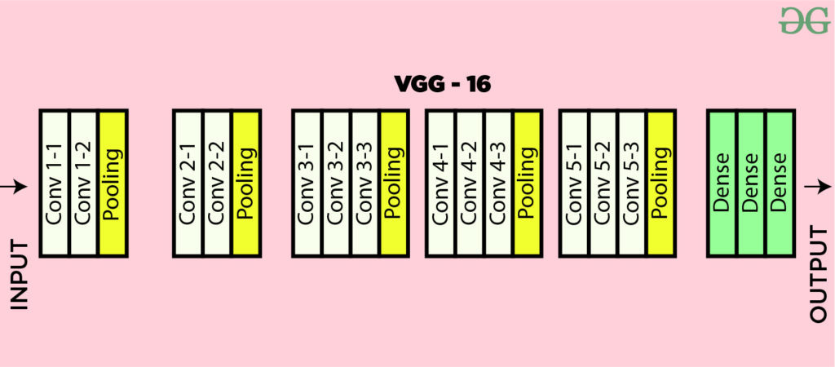
VGG-16 architecture Map
Here’s a breakdown of the VGG-16 architecture based on the provided details:
- Input Layer:
Input dimensions: (224, 224, 3)
- Convolutional Layers (64 filters, 3×3 filters, same padding):
Two consecutive convolutional layers with 64 filters each and a filter size of 3×3.
Same padding is applied to maintain spatial dimensions.
- Max Pooling Layer (2×2, stride 2):
Max-pooling layer with a pool size of 2×2 and a stride of 2.
- Convolutional Layers (128 filters, 3×3 filters, same padding):
Two consecutive convolutional layers with 128 filters each and a filter size of 3×3.
- Max Pooling Layer (2×2, stride 2):
Max-pooling layer with a pool size of 2×2 and a stride of 2.
- Convolutional Layers (256 filters, 3×3 filters, same padding):
Two consecutive convolutional layers with 256 filters each and a filter size of 3×3.
- Convolutional Layers (512 filters, 3×3 filters, same padding):
Two sets of three consecutive convolutional layers with 512 filters each and a filter size of 3×3.
- Max Pooling Layer (2×2, stride 2):
Max-pooling layer with a pool size of 2×2 and a stride of 2.
- Stack of Convolutional Layers and Max Pooling:
Two additional convolutional layers after the previous stack.
Filter size: 3×3.
- Flattening:
Flatten the output feature map (7x7x512) into a vector of size 25088.
- Fully Connected Layers:
- Three fully connected layers with ReLU activation.
- First layer with input size 25088 and output size 4096.
- Second layer with input size 4096 and output size 4096.
- Third layer with input size 4096 and output size 1000, corresponding to the 1000 classes in the ILSVRC challenge.
- Softmax activation is applied to the output of the third fully connected layer for classification.
This architecture follows the specifications provided, including the use of ReLU activation function and the final fully connected layer outputting probabilities for 1000 classes using softmax activation.

VGG-16 Configuration:
The main difference between VGG-16 configurations C and D lies in the use of filter sizes in some of the convolutional layers. While both versions predominantly use 3×3 filters, in version D, there are instances where 1×1 filters are used instead. This slight variation results in a difference in the number of parameters, with version D having a slightly higher number of parameters compared to version C. However, both versions maintain the overall architecture and principles of the VGG-16 model.
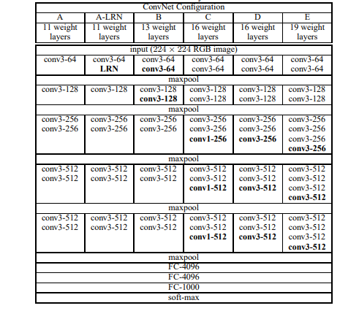
Different VGG Configuration

Object Localization In Image:
To perform localization, we need to replace the class score by bounding box location coordinates. A bounding box location is represented by the 4-D vector (centre coordinates(x,y), height, width). There are two versions of localization architecture, one is bounding box is shared among different candidates (the output is 4 parameter vector) and the other is a bounding box is class-specific (the output is 4000 parameter vector). The paper experimented with both approaches on VGG -16 (D) architecture. Here we also need to change loss from classification loss to regression loss functions (such as MSE) that penalize the deviation of predicted loss from the ground truth.
Results: VGG-16 was one of the best performing architectures in the ILSVRC challenge 2014.It was the runner up in the classification task with a top-5 classification error of 7.32% (only behind GoogLeNet with a classification error of 6.66%). It was also the winner of localization task with 25.32% localization error.

5.2 Sample Code:
ShipDetection.py
#import required python classes and packages
import tkinter
from tkinter import *
from tkinter import filedialog
import json
import matplotlib.pyplot as plt
import os
import sys
import numpy as np
import cv2
import pickle
from PIL import Image, ImageDraw
import tensorflow as tf
from keras.models import Sequential, model_from_json, Model
from keras.layers import Dense, Flatten, Activation, Dropout, Input, Conv2D, MaxPooling2D
from keras.utils import np_utils
from keras.optimizers import Adam
from keras import layers
from keras.applications.vgg16 import VGG16
from keras.applications import ResNet50
from sklearn.metrics import precision_score, recall_score, f1_score, accuracy_score
from sklearn.model_selection import train_test_split

#define global variables
precision = []
recall = []
fscore = []
accuracy = []
global filename, labels
global X, Y
global X_train, X_test, y_train, y_test
global frcnn, extension_vgg
global pictureTensor

def uploadDataset():
global filename, labels, X, Y
text_widget.delete(1.0, END)
filename = filedialog.askopenfilename(initialdir='Dataset')
pathlabel = Label(window, text=filename, bg='white', font=('times', 13, 'bold'))
pathlabel.place(x=20, y=100)

file = open(filename, 'r')
data = json.load(file)
text_widget.insert(END, f"{filename} loaded...\n")
text_widget.insert(END, f"Dataset uploaded Successfully.\n")

#extract one signal from data and convert to image
signal_data = np.array(data['data']).astype('uint8')
labels = np.array(data['labels']).astype('uint8')
location = np.array(data['locations']).astype('uint8')
text_widget.insert(END, f"Total ships signals found in data: {str(signal_data.shape[0])}")

channel = 3
width = 80
height = 80
X = signal_data.reshape([-1, channel, width, height])

sample_image = X[3].transpose([2,1,0])
lab = cv2.cvtColor(sample_image, cv2.COLOR_RGB2LAB)
a_component = lab[:,:,1]
th = cv2.threshold(a_component,140,255,cv2.THRESH_BINARY)[1]
blur = cv2.GaussianBlur(th,(13,13), 11)
heatmap_img = cv2.applyColorMap(blur, cv2.COLORMAP_HSV)

plt.imshow(heatmap_img)
plt.axis('off')
plt.show()
return None

def preprocessDataset():
global labels, X, Y, X_train, X_test, y_train, y_test
Y = np_utils.to_categorical(labels, 2)
indexes = np.arange(X.shape[0])
np.random.shuffle(indexes)
X = X[indexes].transpose([0,2,3,1])
Y = Y[indexes]
X = X / 255
text_widget.delete(1.0, END)
text_widget.insert(END,"Dataset is Preprocessed Successfully...\n")
X_train, X_test, y_train, y_test = train_test_split(X, Y, test_size=0.2)
text_widget.insert(END,"Dataset Splitted into 80% dataset for training and 20% for testing\n")
text_widget.insert(END,f"Training Size (80%): {str(X_train.shape[0])}\n")
text_widget.insert(END,f"Testing Size (20%): {str(X_test.shape[0])}\n")
return None

def calculateMetrics(algorithm, predict, testY):
p = precision_score(testY, predict,average='macro') * 100
r = recall_score(testY, predict,average='macro') * 100
f = f1_score(testY, predict,average='macro') * 100
a = accuracy_score(testY,predict)*100
text_widget.delete(1.0, END)
text_widget.insert(END, f"{algorithm+' Accuracy : '+str(a)}\n")
text_widget.insert(END, f"{algorithm+' Precision : '+str(p)}\n")
text_widget.insert(END, f"{algorithm+' Recall : '+str(r)}\n")
text_widget.insert(END, f"{algorithm+' FSCORE : '+str(f)}\n")
accuracy.append(a)
precision.append(p)
recall.append(r)
fscore.append(f)
return None

def ResNet50Algorithm():
global X_train, X_test, y_train, y_test, frcnn
resnet = ResNet50(include_top=False, weights=None, input_shape=(X_train.shape[1], X_train.shape[2], X_train.shape[3]))
for layer in resnet.layers:
layer.trainable = False
frcnn = resnet.output
frcnn = layers.GlobalAveragePooling2D()(frcnn)
frcnn = layers.Dense(128, activation='relu')(frcnn)
predictions = layers.Dense(1, activation='softmax')(frcnn)
frcnn = Model(resnet.input, predictions)
optimizer = Adam()
frcnn.compile(loss='binary_crossentropy', optimizer=optimizer, metrics=['accuracy'])
frcnn = tf.keras.models.load_model('models/rcnn.h5py')
predict = frcnn.predict(X_test)
predict = np.argmax(predict, axis=1)
y_test1 = np.argmax(y_test, axis=1)
calculateMetrics("Propose FRCNN", predict, y_test1)
return None

def vgg16Algorithm():
global X_train, X_test, y_train, y_test, extension_vgg
#load base VGG16 model
vgg_model = VGG16(weights='imagenet', include_top=False, input_shape=(X_train.shape[1], X_train.shape[2], X_train.shape[3]))
extension_vgg = vgg_model.get_layer('block2_pool').output
extension_vgg = Conv2D(filters=64, kernel_size=(3,3), activation='relu')(extension_vgg)
extension_vgg = MaxPooling2D(pool_size=(2,2))(extension_vgg)
extension_vgg = Flatten()(extension_vgg)
extension_vgg = Dense(256, activation='relu')(extension_vgg)
extension_vgg = Dropout(0.5)(extension_vgg)
extension_vgg = Dense(2, activation='softmax')(extension_vgg)

#Corrected line
extension_vgg = Model(inputs=vgg_model.input, outputs=extension_vgg)

opt = Adam(learning_rate=0.0001)
extension_vgg.compile(loss='categorical_crossentropy', optimizer=opt, metrics=['accuracy'])

#Load pretrained weights
with open('models/vgg_model.json', "r") as json_file:
loaded_model_json = json_file.read()
extension_vgg = model_from_json(loaded_model_json)
extension_vgg.load_weights("models/vgg_weights.h5")

predict = extension_vgg.predict(X_test)
predict = np.argmax(predict, axis=1)
y_test1 = np.argmax(y_test, axis=1)
calculateMetrics("Extension VGG16 Based FRCNN", predict, y_test1)

# Functions for plotting graphs
def getTrainingResult(history):
with open(history, 'rb') as f:
history = pickle.load(f)
return history['val_accuracy'], history['val_loss']

def accuracyGraph():
text_widget.delete(1.0, END)
resnet_frcnn_acc, resnet_frcnn_loss = getTrainingResult('models/rcnn_history.pckl')
vgg_frcnn_acc, vgg_frcnn_loss = getTrainingResult('models/vgg_history.pckl')
plt.figure(figsize=(10,6))
plt.grid(True)
plt.xlabel('Epoch/Iterations')
plt.ylabel('Accuracy')
plt.plot(resnet_frcnn_acc, color='green', marker='o')
plt.plot(vgg_frcnn_acc, color='blue', marker='o')
plt.legend(['Propose Resnet50-FRCNN', 'Extension VGG16-FRCNN'], loc='upper left')
plt.title('Propose & Extension Training Accuracy Graph')
plt.show()
return None

def lossGraph():
resnet_frcnn_acc, resnet_frcnn_loss = getTrainingResult('models/rcnn_history.pckl')
vgg_frcnn_acc, vgg_frcnn_loss = getTrainingResult('models/vgg_history.pckl')
plt.figure(figsize=(10,6))
plt.grid(True)
plt.xlabel('Epoch/Iterations')
plt.ylabel('Loss')
plt.plot(resnet_frcnn_loss, color='green', marker='o')
plt.plot(vgg_frcnn_loss, color='blue', marker='o')
plt.legend(['Propose Resnet50-FRCNN', 'Extension VGG16-FRCNN'], loc='upper left')
plt.title('Propose & Extension Training Loss Graph')
plt.show()
return None

def comparisonGraph():
import pandas as pd
df = pd.DataFrame([['Propose Resnet50-FRCNN','Precision',precision[0]],['Propose Resnet50-FRCNN','Recall',recall[0]],['Propose Resnet50-FRCNN','F1 Score',fscore[0]],['Propose Resnet50-FRCNN','Accuracy',accuracy[0]],
['Extension VGG16-FRCNN','Precision',precision[1]],['Extension VGG16-FRCNN','Recall',recall[1]],['Extension VGG16-FRCNN','F1 Score',fscore[1]],['Extension VGG16-FRCNN','Accuracy',accuracy[1]],
],columns=['Algorithms','Parameters','Value'])
df.pivot("Parameters", "Algorithms", "Value").plot(kind='bar')
plt.title("Propose & Extension Performance Graph")
plt.show()
return None

# Ship detection helper functions
def extractShip(xx, yy):
areaStudy = np.arange(3*80*80).reshape(3, 80, 80)
for row in range(80):
for col in range(80):
areaStudy[0][row][col] = pictureTensor[0][yy+row][xx+col]
areaStudy[1][row][col] = pictureTensor[1][yy+row][xx+col]
areaStudy[2][row][col] = pictureTensor[2][yy+row][xx+col]
areaStudy = areaStudy.reshape([-1, 3, 80, 80])
areaStudy = areaStudy.transpose([0,2,3,1])
areaStudy = areaStudy / 255
return areaStudy

def notNear(xx, yy, src, ship_coordinates):
results = True
for i in ship_coordinates:
if xx+src > i[0][0] and xx-src < i[0][0] and yy+src > i[0][1] and yy-src < i[0][1]:
results = False
return results

def showShip(xx, yy, accuracy, thickness=15):
global pictureTensor
for i in range(80):
for j in range(3):
for k in range(thickness):
pictureTensor[j][yy+i][xx-k] = -1
pictureTensor[j][yy+i][xx+k+80] = -1
pictureTensor[j][yy-k][xx+i] = -1
pictureTensor[j][yy+k+80][xx+i] = -1

def shipDetection():
global pictureTensor, extension_vgg
test_img = filedialog.askopenfilename(initialdir='testImage')
image = Image.open(test_img)
pix = image.load()
nspectrum = 3
img_width = image.size[0]
img_height = image.size[1]
picturevector = []
for chanel in range(nspectrum):
for yy in range(img_height):
for xx in range(img_width):
picturevector.append(pix[xx, yy][chanel])

picturevector = np.array(picturevector).astype('uint8')
pictureTensor = picturevector.reshape([nspectrum, img_height, img_width]).transpose(1, 2, 0)

plt.figure(1, figsize=(8, 10))
plt.subplot(2, 1, 1) # Use 2 rows and 1 column layout, first subplot
plt.imshow(pictureTensor)
plt.title("Original Image")
plt.axis('off')
pictureTensor = pictureTensor.transpose(2, 0, 1)
step = 30
ship_coordinates = []
text_widget.insert(END, int((img_height - (80 - step)) / step))
text_widget.insert(END, int((img_width - (80 - step)) / step))
m = 0
for yy in range(int((img_height - (80 - step)) / step)):
if m < 1:
for xx in range(int((img_width - (80 - step)) / step)):
if m < 1:
area = extractShip(xx * step, yy * step)
result = extension_vgg.predict(area)
if result[0][1] > 0.91 and notNear(xx * step, yy * step, 88, ship_coordinates):
ship_coordinates.append([[xx * step, yy * step], result])
text_widget.insert(END, result)
plt.subplot(2, 1, 2)
plt.imshow(area[0])
plt.title("Detected Ship Area")
plt.axis('off')
m += 1
text_widget.insert(END, ship_coordinates)
for e in ship_coordinates:
showShip(e[0][0], e[0][1], e[1][0][1])
pictureTensor = pictureTensor.transpose(1,2,0)
pictureTensor.shape
(1777, 2825, 3)
plt.figure(figsize = (8, 10))
plt.imshow(pictureTensor)
plt.title("Final Image with Detected Ships")
plt.axis('off')
plt.show()

# Tkinter GUI
window = tkinter.Tk()
window.title("Marine Safety Enhancement Using Faster R-CNN with VGG16 for Ship Detection from Airborne Radar Signals")
window.geometry("1250x900")
window.config(bg='#C7FFE6')

font = ('times', 24)
Title = Label(window, text = "Marine Safety Enhancement Using Faster R-CNN with VGG16 for Ship Detection from Airborne Radar Signals", bg = 'black', fg = 'white')
Title.config(font=font)
Title.config(height=2, width=120)
Title.place(relx=0.5, rely=0, anchor='n')

text_widget = Text(window, height=30, width=100, bg = 'black', fg = 'white')
text_widget.place(x = 20, y=150)

font1 = ('times', 13, 'bold')
Button(window, text="Upload Dataset", font=font1, bg='black', fg='white', command=uploadDataset).place(x=900, y=150)
Button(window, text="Preprocess Dataset", font=font1, bg='black', fg='white', command=preprocessDataset).place(x=900, y=200)
Button(window, text="Proposed ResNet50 based FRCNN", font=font1, bg='black', fg='white', command=ResNet50Algorithm).place(x=900, y=250)
Button(window, text="Extension VGG16 based FRCNN", font=font1,bg='black', fg='white', command=vgg16Algorithm).place(x=900, y=300)
Button(window, text="Accuracy Graph", font=font1, bg='black', fg='white', command=accuracyGraph).place(x=900, y=350)
Button(window, text="Loss Graph", font=font1, bg='black', fg='white', command=lossGraph).place(x=900, y=400)
Button(window, text="Comparison Graph", font=font1, bg='black', fg='white', command=comparisonGraph).place(x=900, y=450)
Button(window, text="Ship Detection", font=font1, bg='black', fg='white', command=shipDetection).place(x=900, y=500)

window.mainloop()

6. TESTING
Implementation and Testing:
Implementation is one of the most important tasks in project is the phase in which one has to be cautions because all the efforts undertaken during the project will be very interactive. Implementation is the most crucial stage in achieving successful system and giving the users confidence that the new system is workable and effective. Each program is tested individually at the time of development using the sample data and has verified that these programs link together in the way specified in the program specification. The computer system and its environment are tested to the satisfaction of the user.

Implementation

The implementation phase is less creative than system design. It is primarily concerned with user training, and file conversion. The system may be requiring extensive user training. The initial parameters of the system should be modifies as a result of a programming. A simple operating procedure is provided so that the user can understand the different functions clearly and quickly. The different reports can be obtained either on the inkjet or dot matrix printer, which is available at the disposal of the user. The proposed system is very easy to implement. In general implementation is used to mean the process of converting a new or revised system design into an operational one.

Testing
Testing is the process where the test data is prepared and is used for testing the modules individually and later the validation given for the fields. Then the system testing takes place which makes sure that all components of the system property functions as a unit. The test data should be chosen such that it passed through all possible condition. Actually testing is the state of implementation which aimed at ensuring that the system works accurately and efficiently before the actual operation commence. The following is the description of the testing strategies, which were carried out during the testing period.

System Testing
Testing has become an integral part of any system or project especially in the field of information technology. The importance of testing is a method of justifying, if one is ready to move further, be it to be check if one is capable to with stand the rigors of a particular situation cannot be underplayed and that is why testing before development is so critical. When the software is developed before it is given to user to use the software must be tested whether it is solving the purpose for which it is developed. This testing involves various types through which one can ensure the software is reliable. The program was tested logically and pattern of execution of the program for a set of data are repeated. Thus the code was exhaustively checked for all possible correct data and the outcomes were also checked.

Module Testing
To locate errors, each module is tested individually. This enables us to detect error and correct it without affecting any other modules. Whenever the program is not satisfying the required function, it must be corrected to get the required result. Thus all the modules are individually tested from bottom up starting with the smallest and lowest modules and proceeding to the next level. Each module in the system is tested separately. For example the job classification module is tested separately. This module is tested with different job and its approximate execution time and the result of the test is compared with the results that are prepared manually. The comparison shows that the results proposed system works efficiently than the existing system. Each module in the system is tested separately. In this system the resource classification and job scheduling modules are tested separately and their corresponding results are obtained which reduces the process waiting time.
Integration Testing
After the module testing, the integration testing is applied. When linking the modules there may be chance for errors to occur, these errors are corrected by using this testing. In this system all modules are connected and tested. The testing results are very correct. Thus the mapping of jobs with resources is done correctly by the system.
Acceptance Testing
When that user fined no major problems with its accuracy, the system passers through a final acceptance test. This test confirms that the system needs the original goals, objectives and requirements established during analysis without actual execution which elimination wastage of time and money acceptance tests on the shoulders of users and management, it is finally acceptable and ready for the operation
Test Case Id | Test Case Name | Test Case Desc. | Test Steps |  |  | Test Case Status | Test Priority
 |  |  | Step | Expected | Actual
01 | Upload Dataset | Test whether Dataset is uploaded or not into the system | If the Dataset may not uploaded | We cannot do further operations | Dataset uploaded we will do further operations | High | High
02 | Preprocess Dataset | Test whether the Pre-process Dataset Successfully or not | If the Pre-process Dataset may not Run Successfully | We cannot do further operations | we will do further  operations | High | High
03 | Train proposed ResNet50 based FRCNN | Test whether ResNet50 based FRCNN Algorithm Run Successfully or not | If the  ResNet50 based FRCNN Algorithm may not Run Successfully | We cannot do further operations | we will do further  operations | High | High
04 | Train Extension VGG16 based FRCNN | Test whether VGG16 based FRCNN Algorithm Run Successfully or not | If the VGG16 based FRCNN Algorithm may not Run Successfully | We cannot do further operations | we will do further  operations | High | High
05 | Accuracy Graph | Test whether Accuracy graph display Successfully or not | If the Accuracy graph may not display Successfully | We cannot do further operations | we will do further  operations | High | High
06 | Loss Graph | Test whether loss graph display Successfully or not | If the loss graph may not display Successfully | We cannot do further operations | we will do further  operations | High | High
07 | Comparison graph | Test whether comparison graph display Successfully or not | If the comparison graph may not display Successfully | We cannot do further operations | we will do further  operations | High | High
08 | Ship Detection | Test whether ship detected Successfully or not | If the ship may not detected Successfully | We cannot do further operations | we will do further  operations | High | High

7.SCREENSHOTS:
To run these project double click on run.bat file
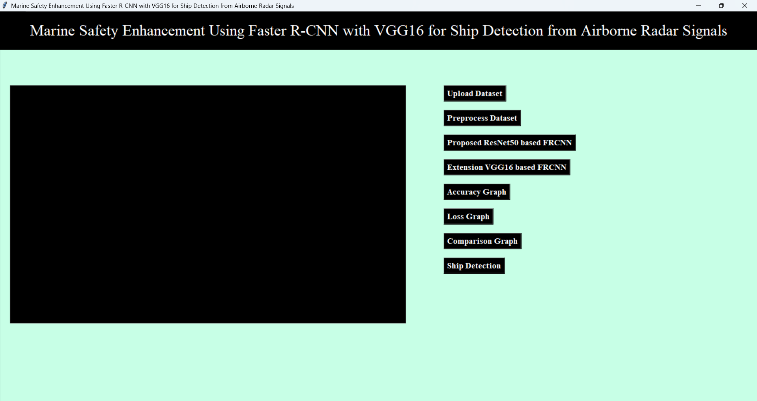
In above screen click on ‘Upload Dataset’ button to get below output
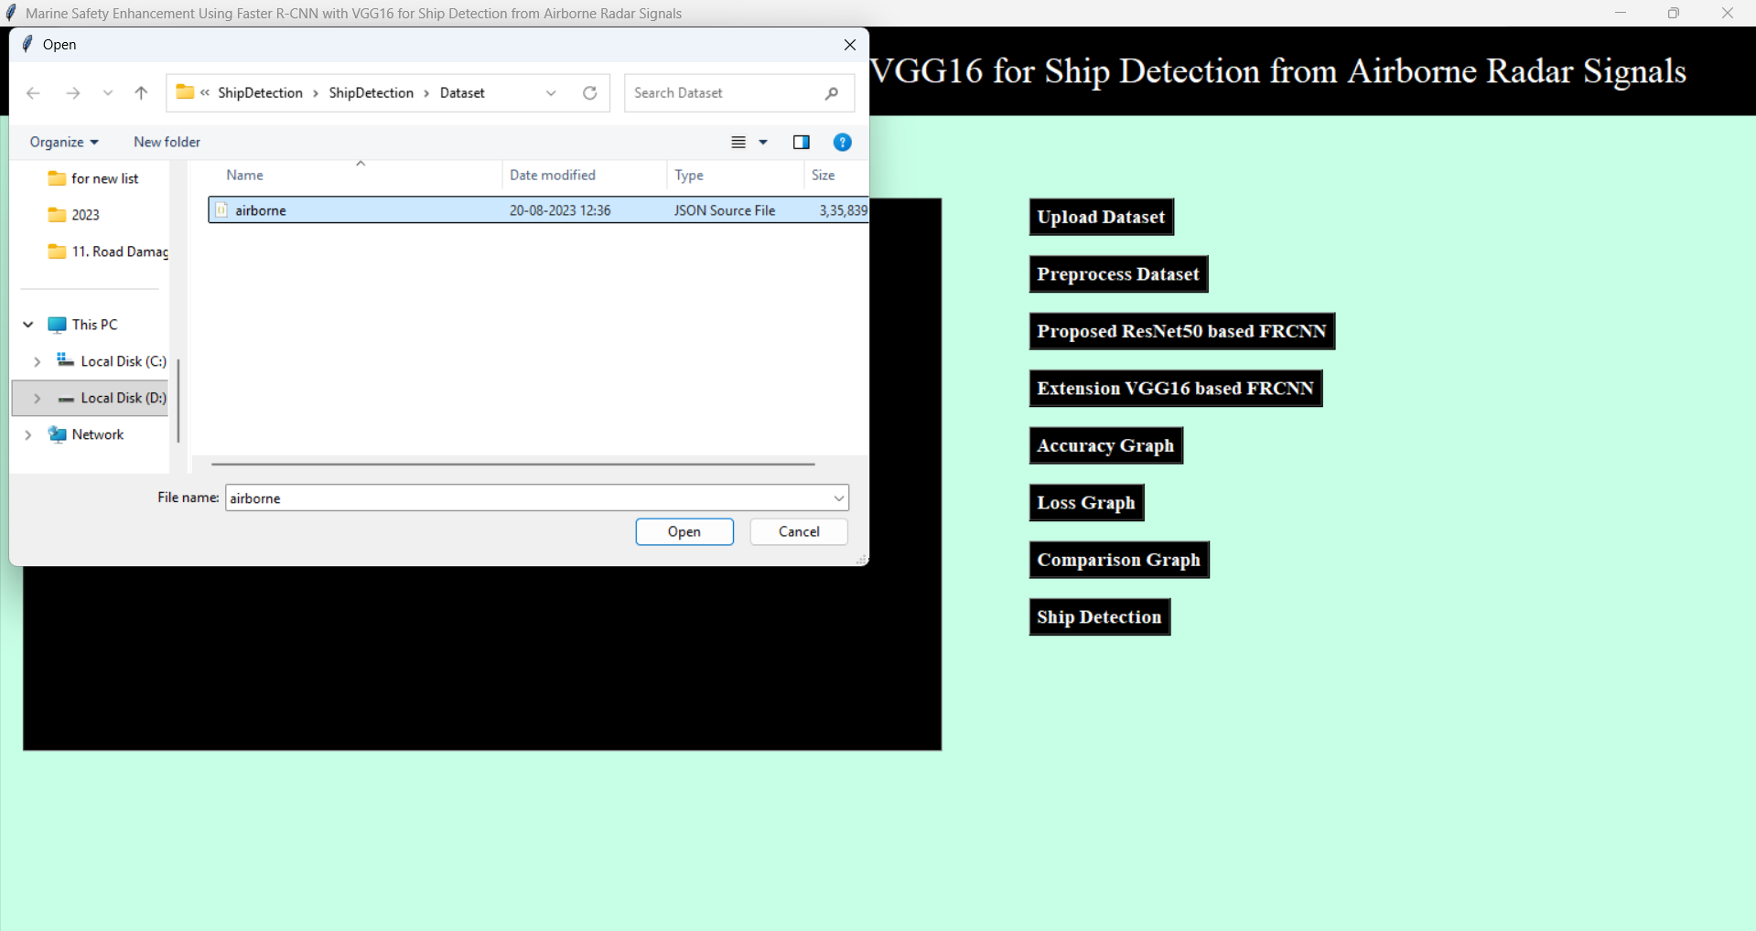
In above screen select ‘airborne.json’ file dataset and click on open button then we will get below output
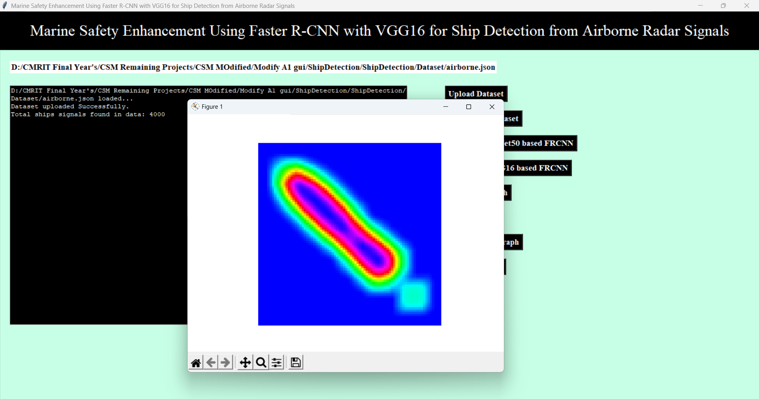
In above screen loading dataset and then extracting key from dataset where data key contains signals and labels contains class label values and then displaying total ship signals found in dataset as 4000. A graph represents converting all signals in to images and then displaying sample image. Now click on Preprocess Dataset button to get below result
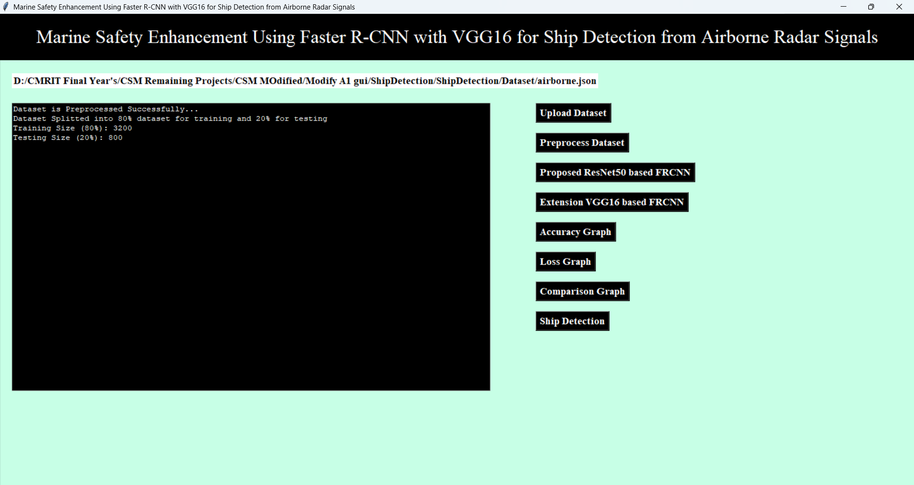
In above screen pre-processing all images like shuffling and normalizing and then displaying normalize values. After pre-processing we split the dataset into training and testing dataset. Now click on ‘Resnet50 based FRCNN’ to get below result
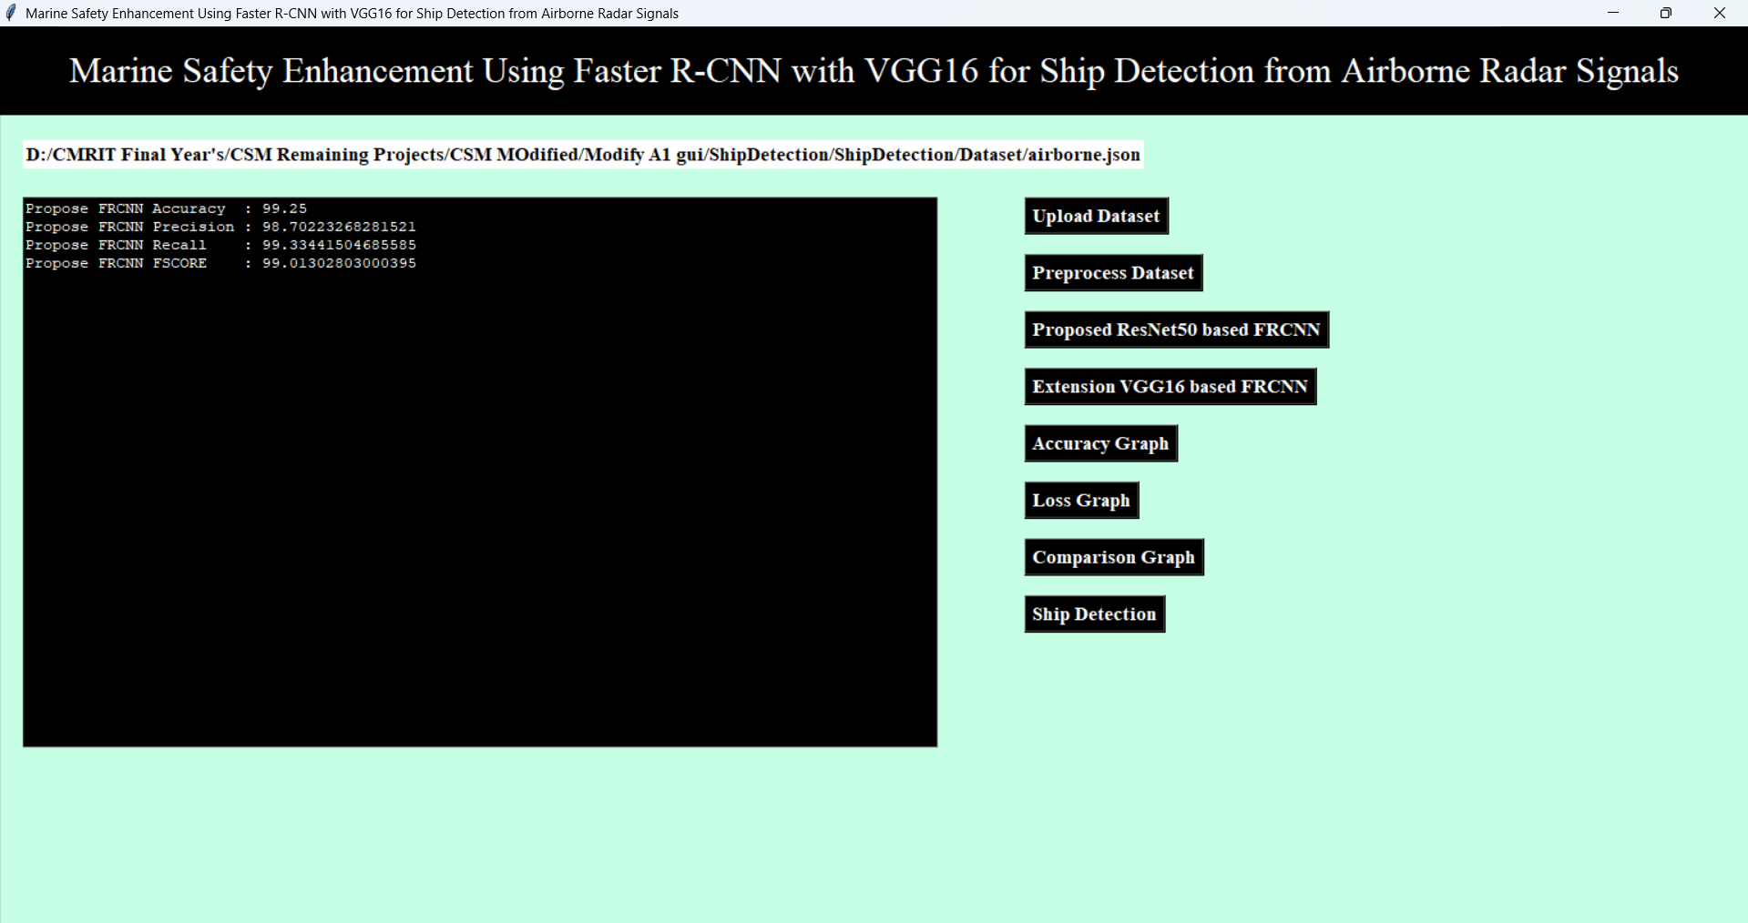
In above screen training FRCNN by using Resnet50 as the based model and after testing this model we can see propose FRCNN accuracy is 98+% or and can see other metrics also. Now click on ‘VGG16 based FRCNN’ to get below result
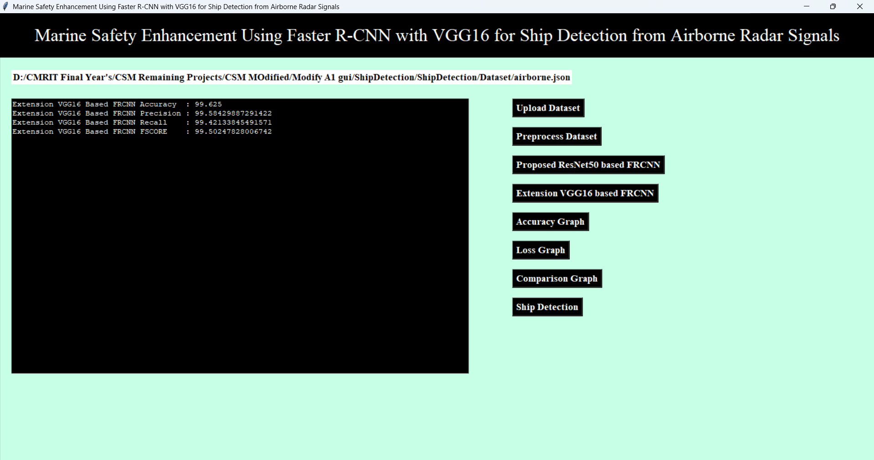
In above screen training extension FRCNN by using VGG16 as the based model and after executing this model with extension model we got 99+% accuracy (always we will get accuracy higher than proposed method and sometime we will get 100% accuracy). Now click on ‘Accuracy Graph’ to get below result
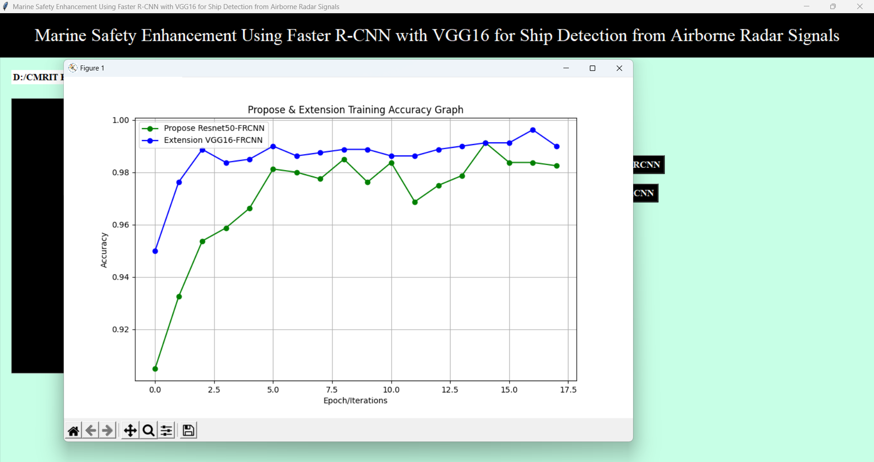

Above is the Propose FRCNN and Extension FRCCN training graph where x-axis represents training epoch and y-axis represents training accuracy. Green line represents propose FRCNN accuracy and blue line represents extension FRCNN accuracy and with each increasing epoch accuracy got increase for both models but extension got high accuracy. Now click on ‘Loss Graph’ to get below result
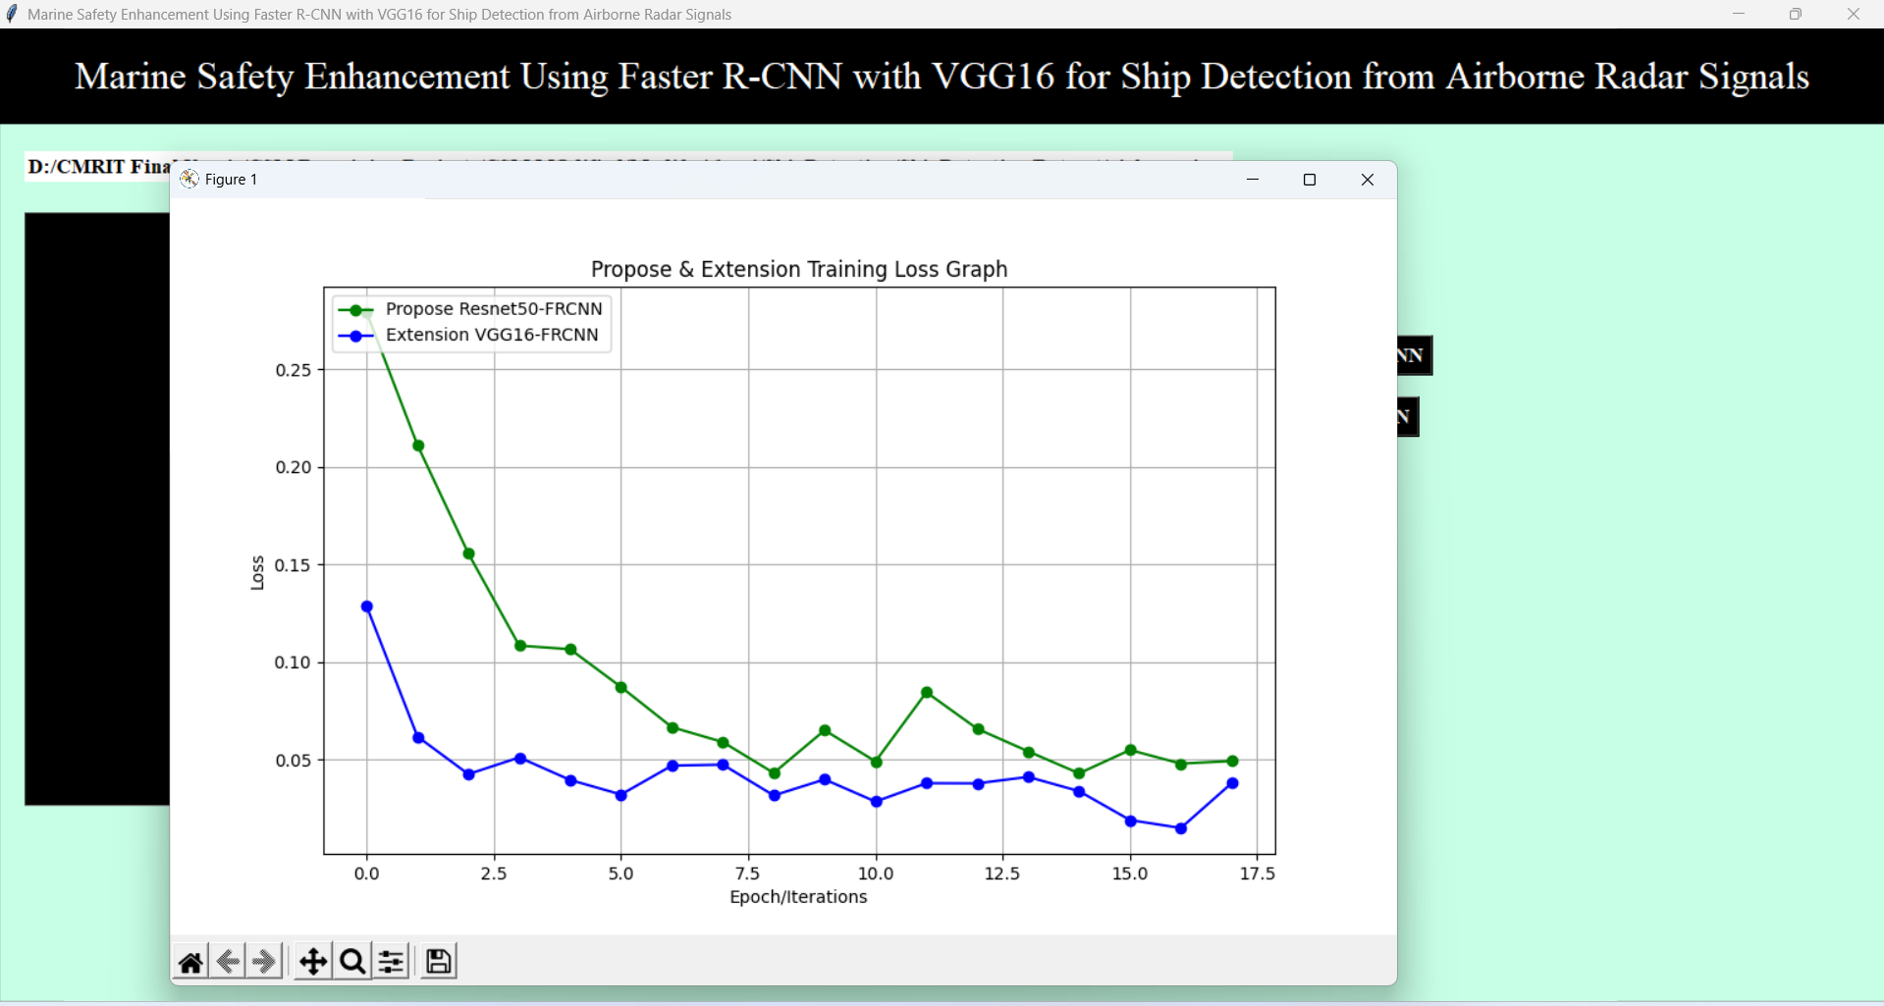
Above is the Loss graph for both model and extension got less loss compare to propose algorithm. Now click on ‘Comaparison Graph’ to get below result
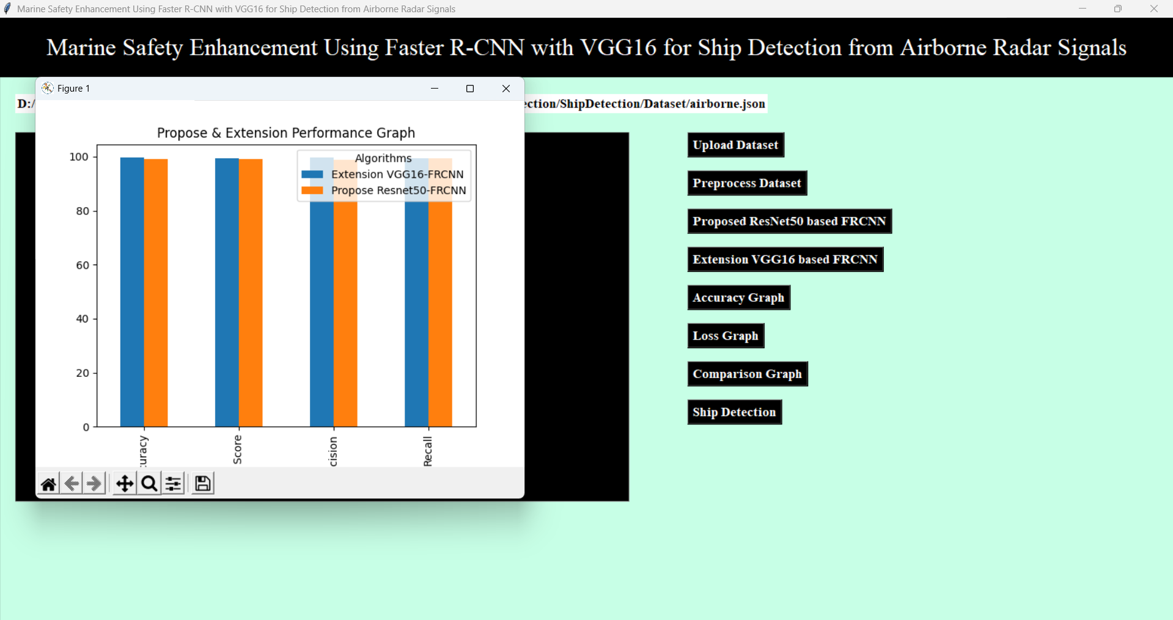
In above graph x-axis represents algorithm names and y-axis represents accuracy and other metric in different colour bars displaying both algorithm performance in graphical format. Now click on ‘Ship Detection’ to get below result
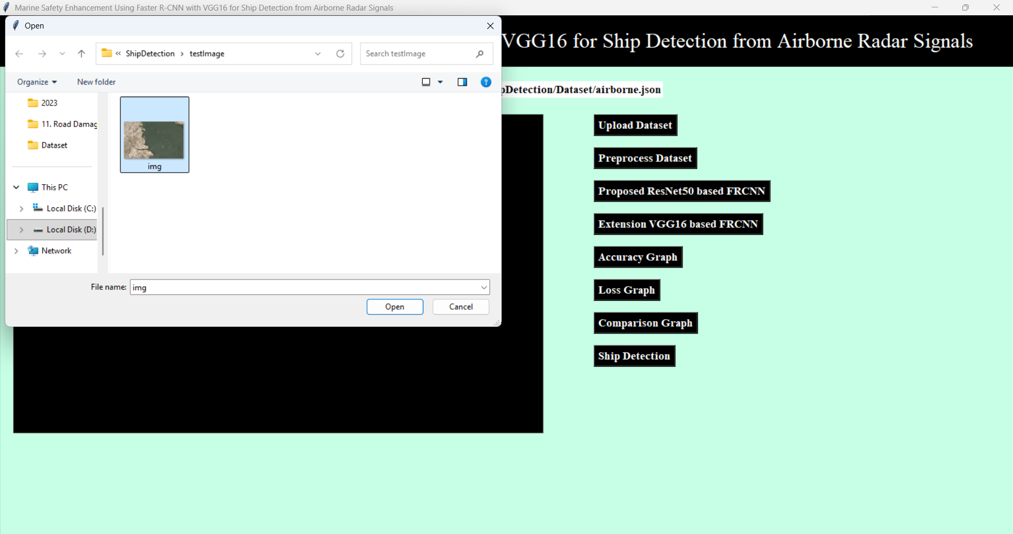
In above screen giving input image for detection and after detection will get below output
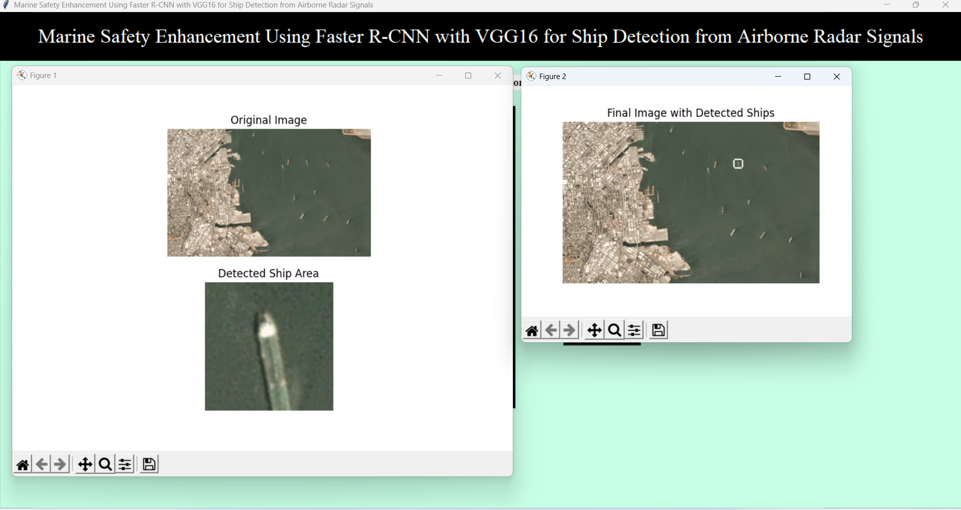
In above screen detected ship displaying with while bold colour bounding box and it classify as ship and putting bounding boxes across it. In image lots of ships are there and for all detection model may take hours of time so we are detecting only one ship and then breaking the loop.
Note: above image is captured from airborne flight

8. CONCLUSION:
This letter presents two novel object-oriented ship detectors based on the Faster R-CNN deep learning framework. The ship detectors are trained and tested using eleven real X-band RC radar datasets acquired by DLR’s airborne systems F-SAR and DBFSAR. The first ship detector operates on RC radar data in time domain, while the second ship detector operates in Doppler domain. Both detectors were able to detect all the AIS carrying ships contained in the testing datasets, achieving high r values even in complex scenarios with several man-made objects. Compared to the state-of-the-art CFAR-based method from [6], which operates in Doppler domain, the proposed ship detector in Doppler domain was able to provide less false detections and reduced processing time. Nevertheless, it has to be pointed out that a bias in the precision p and the F1-score may be expected since the detections obtained from potential ship objects without AIS transponder are assumed as FP.

9. REFERENCES:
1. Revised Guidelines for The Onboard Operational Use of Shipborne Automatic Identification Systems (AIS), London, U.K., pp. 1-17, 2015.

2. H. Greidanus, "Satellite imaging for maritime surveillance of the European seas" in Remote Sensing of the European Seas, Dordrecht, The Netherlands: Springer, pp. 343-358, 2008.

3. A. Moreira, P. Prats-Iraola, M. Younis, G. Krieger, I. Hanse and K. P. Papathanassiou, "A tutorial on synthetic aperture radar", IEEE Geosocial. Remote Sens. Mag., vol. 1, no. 1, pp. 6-43, Mar. 2013.

4. M. F. Finglas and C. E. Brown, "Review of ship detection from airborne platforms", Can. J. Remote Sens., vol. 27, no. 4, pp. 379-385, 2001.

5. D. J. Crisp, "The state-of-the-art in ship detection in synthetic aperture radar imagery", 2004.

6. S. K. Joshi, S. V. Baumgartner, A. Barros Cardoso da Silva and G. Krieger, "Range-Doppler based CFAR ship detection with automatic training data selection", Remote Sens., vol. 11, no. 11, pp. 1270-1305, 2019.

7. F. Sharifzadeh, G. Akbari Zadeh and Y. Seifi Kavian, "Ship classification in SAR images using a new hybrid CNN–MLP classifier", J. Indian Soc. Remote Sens., vol. 47, pp. 551-562, Oct. 2019.

8. T. Hoeser, F. Bachofer and C. Kuenzer, "Object detection and image segmentation with deep learning on Earth observation data: A review—Part II: Applications", Remote Sens., vol. 12, no. 18, pp. 3053-3099, 2020.
9. X. X. Zhu et al., "Deep learning meets SAR: Concepts models pitfalls and perspectives", IEEE Geosocial. Remote Sens. Mag., vol. 9, no. 4, pp. 143-172, Dec. 2021.

10. S. Ren, K. He, R. Kirchick and J. Sun, "Faster R-CNN: Towards real-time object detection with region proposal networks", IEEE Trans. Pattern Anal. Mach. Intel., vol. 39, no. 6, pp. 1137-1149, Jun. 2017.

11. X. Leng, J. Wang, K. Ji and G. Kuang, "Ship detection in range-compressed SAR data", Proc. IEEE Int. Geosocial. Remote Sens. Symp. (IGARSS), pp. 2135-2138, Jul. 2022.

12. K. He, X. Zhang, S. Ren and J. Sun, "Deep residual learning for image recognition", Proc. IEEE Conf. Comput. Vis. Pattern Recognin. (CVPR), pp. 770-778, Jun. 2016.

13. A. Rieger et al., "Very-high-resolution airborne synthetic aperture radar imaging: Signal processing and applications", Proc. IEEE, vol. 101, no. 3, pp. 759-783, Mar. 2013.

14. A. Rieger et al., "Current status of DLR’s new F-SAR sensor", Proc. 8th Eur. Conf. Synth. Aperture Radar (EUSAR), pp. 1078-1081, Jun. 2010.

15. A. Rieger et al., "The high-resolution digital-beamforming airborne SAR system DBFSAR", Remote Sens., vol. 12, no. 11, pp. 1710, 2020.

16. T.-Y. Lin et al., "Microsoft COCO: Common objects in context", Proc. Eur. Conf. Comput. Vis. (ECCV), pp. 1-15, 2014.

17. J. Jiao et al., "A densely connected end-to-end neural network for multiscale and multiscreen SAR ship detection", IEEE Access, vol. 6, pp. 20881-20892, 2018.

